Jens Schuster

RONDOS X JUEGO DE Posición

August 2016

mail@jensschuster.de
V 1.5.8

5 + 5N vs. 5 WITH POSITION CHANGE

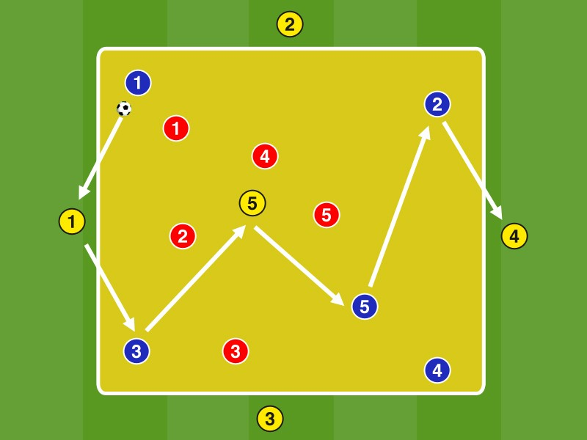Blue plays the field in 5: 5 plus 5 neutral Yellow (one in the field and 4 outside) to red with a maximum of 2 contacts.

If it is possible Red conquer the ball, to adapt to a neutral on the outer positions change positions with red yellow in the neutral position (4 players outside and inside of the box). Yellow Stars in the field continued in possession, and Blue plays in the field against the ball.

At the beginning of the coach says the team that currently contesting the ball always plays on. Later, it is then the job of the players to constantly see new Überzahl- / outnumbered conditions and to respond.

The crew of the neutral role into the possession of the ball roller (top yellow) changes to immediately fan out in the field and pay particular attention to open registration lines at the 1st pass the ball profit to turn into a stable possession can.

Decisive in this rondo form in addition to direct counter pressing with ball loss Fanning in possession, to cast a net in order to produce optimum spacing and pass triangles between players can. Pay particular attention to equal and opposite movements of the two middle players.

2 MAL 6 vs. 2 TO 6 vs. 1 TO 6 vs. 3 IN THE FIELDS CHANGE AFTER BV

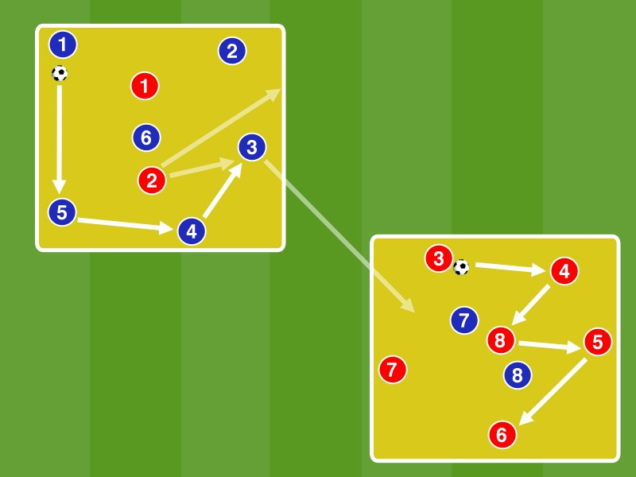Two equal about 10 by 10 meters large fields diagonally offset at a distance of about 7 meters mark.

In both fields is in 6: 2 started in direct game. The player causes a ball loss, changes in the sprint to the other field to defend there. The player who was the longest in the middle of change at a ball profit in the same field to the outside.

It caused so outnumbered ratios of 6: 1 to 6: 3, in exceptional cases, even a 6:. 4 In 6: 1 and 6: 2 is played with 1 contact, with 6: 3 with 2 contacts in 6: 4 in free play.

Players must react in possession game to different outnumbered ratios, and thereby preorienting overlooking the other field to detect an incoming starting Defending early. The players should be coached each other in order to respond best to a further Defending can.

The ball ends occupy the center to create optimal fit lines in a spanned network.

Variant:
- The player who won the ball changes to the outside, not the player who was the longest in the middle
- , Dumbshow 'Ie no commands to the players. So each player is always responsible for its own pre-orientation

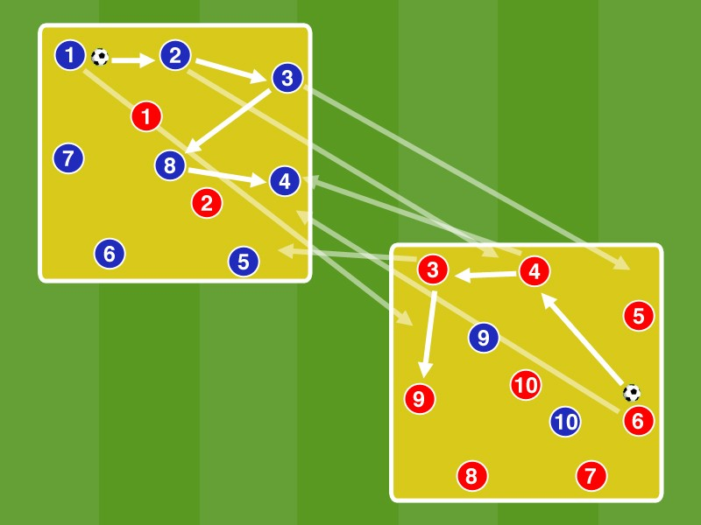Mark Two about 12 times 12 meter playing fields at a distance of about 5 meters.

In both fields is in 8: 2 with 2 contacts began. Each player must change the field after each pass.

The player who caused a loss of the ball to Defending. The Defending which was the longest in the field will change outwardly.

The players should quickly change the positions at a loss of the ball to ensure approximately constant ratios in both fields. At different speed ratios, the game will pause briefly.

The players look for when fields change it, no registration lines served. so you need to weigh up between the fastest and the most meaningful way to the fields change. If they hit the ball at the fields of exchange are (= pass line delivered), they and the passer in the current field to Defending.
The center is to be always busy, to occupy snug lines in a spanned network.
When fields change not the closest position, but meaningful positions to be filled in free rooms.

Variants:
- Direct game / match with alternating 1 and 2 contacts
• 6: 2 (outdoor game) / 7: 1/9: 2 / ...

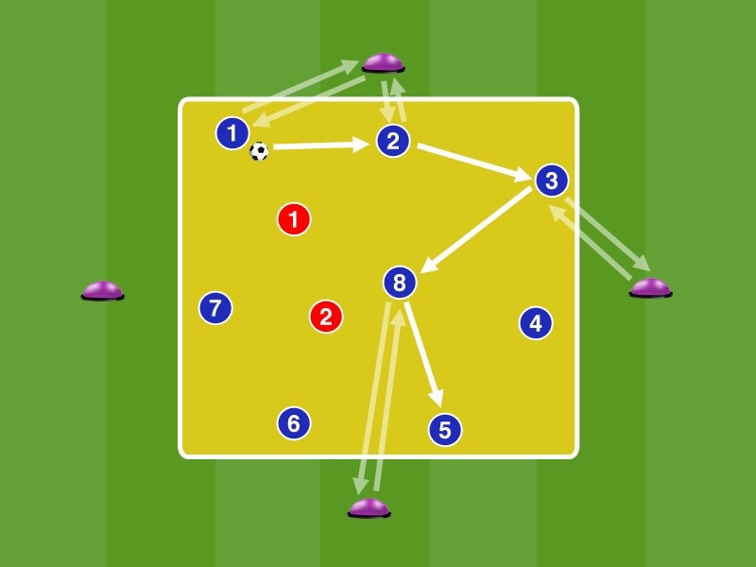Mark A 12 by 12-meter pitch. Approximately 3 meters from the outline position 4 Bosu balls.

In box in an 8: 2 plays a direct game. Each player is running after the pass to a Bosu ball outwards to complete there steps 3 (or any other objects).

Through the additional task after the pass no rebound is let the ball possible, the player must be positioned pre-orientated in the open position so to continue playing for a third party can.

The center is to be always busy, to occupy snug lines in a spanned network.

Variants:
- Instead of using Bosu balls mini hurdles, or various other materials coordination
- Game with 2 contacts

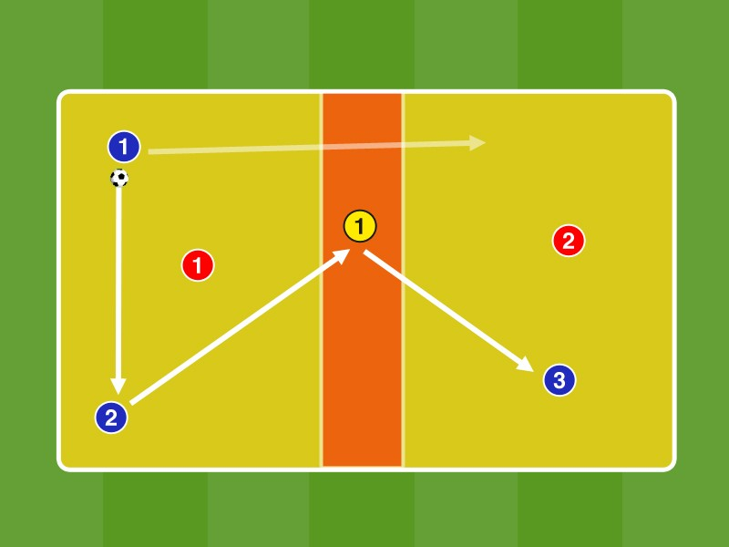A divide 20 by 10 meters large field in 2 halves and mark in the middle of a 3 meters wide central zone.

In box 1 play 2 blue player with the Neutral G1, which may be present only in the central zone against a Red in 3: 1 in the direct game. After at least 5 passes blue may change to B3 in Field 2, where a Blue advancing directly in 3: 1 is further played together with the Neutral G1 to R2.

After 5 ball conquers replace both red 2 blue players. After several passages change the neutrals.

The 3 ball ends should always form a large triangle as possible to span a maximum area. Ask When pass clear in which foot to play to mitzugeben a command (in the ball near foot as command 'clapping blank' and in the ball away as a sign for 'the game from the third party').

Fields change should be prepared by ball Gossip combinations over the neutrals.

B3 runs in box 2 by running feints free to the pass when fields change in the 1: 1 to make impact against the blue opponent can.

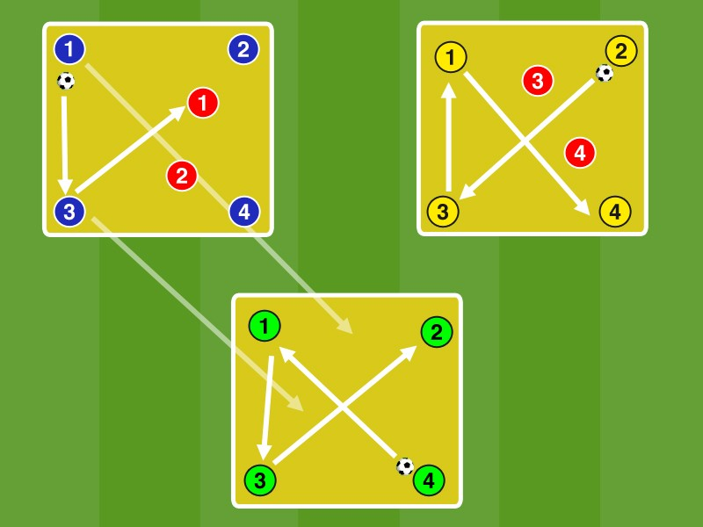3 equal about 10 by 10 meters large fields at a distance of about 2 meters mark. In addition to all three fields put enough spare balls ready.

In box 1 Play 4 Blue against Red 2 in box 2 two yellow against 2 red, while three 4 Green match the ball field.

Once manages the Reds to win the ball (to carry off) change both the possession ends, who last touched the ball in the sprint in the field by no Defending located (here, the field of green) to there in 2 : 4 to defend.

In Field1 2 Blue and Red 2 now form the team's possession ends.
The Greens are oriented while free fit before in the direction of the other two fields in order to be prepared for the attacking from both directions.

Variants:
- Game with 2 contacts
- When winning the ball it is, if it is possible a defensive to pass to 2. Defensive
- Plays the team in possession 10 passes in a row change the defensive the field to the 'free' field in 2: 4 defend
- Conquered red in box 1 of the ball change 2 Red from box 2 in field 1 to there in 4: 2 playing against blue, so it will be always in the same colors for the 4: 2 filled.

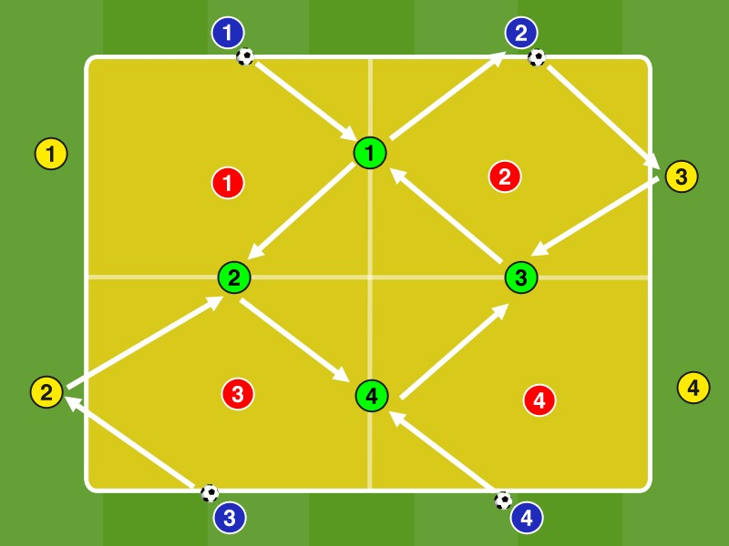An approximately 18 times 18 meters large pitch in 4 equal fields divide.

Position on 4 opposite side lines 4 blue player, the other 4 side lines 4 yellow. position at the middle boundary lines 4 green player. Assign a red Defending each field.

Blue, Red and Green play in each subfield in the 4: 1 with max. 2 contacts against red, the Greens same 'act in each 2 subfields. The Reds are in common their profits ball (ball is out).
After 1 minute switch the positions. The coaches play after a ball is out immediately a new ball.
The Greens are in the best case in the open position, pre-orientated to both fields in order to decide, depending on the game situation can, in which entry of a support from 2: 1 to 3: 1, or from 3: 1 to 4: 1 most important is ,

The Blue and Yellow adjust depending on the positioning of the Greens to their position and coach the Greens, by at least a 3:. 1-over ratio in each field to produce.

Variant:
- Each green player must turn in his' two fields play, ie it may not play in a field 2 passes in succession.

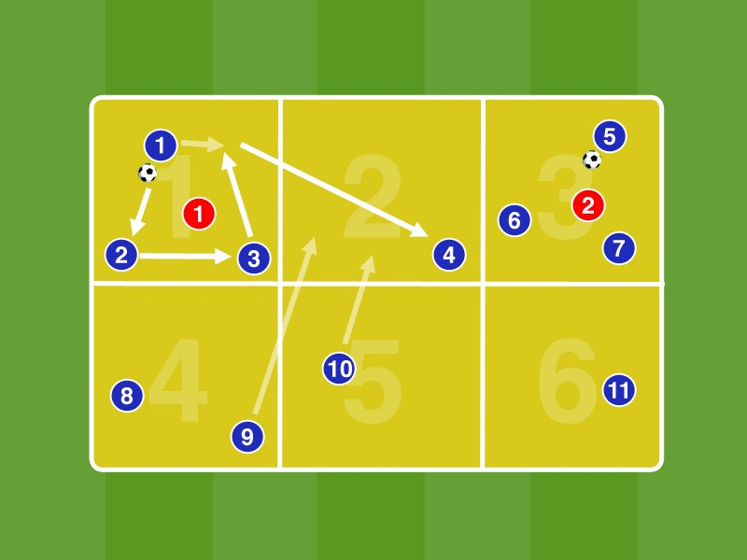A 25 by 15 meters large field in 6 equal fields divide.

In Field 1 and Field 3 at the same time start a 3: 1. After 4 contacts must be changed into a new field by fit on a blue player in the new field. then move into this field Players in the other fields according to it in 3 again: to occupy. 1 After a further 4 contacts the field can be changed again. The red players defend each in the two fields that are being recorded.

Conquered the red player a ball it changes with the player who has made the mistake.

Players must own again 3: 1 producing situations in the fields. For this they must constantly scan the entire field to be optimally oriented. It also requires good communication, the player in possession to tune to who in the respective fields to 3: be succeeded. 1

variations:
- 3: 1 in direct game
- In the field, from which the ball has come, may not be played in the next fields change, so it is blocked for a short time.
- use 2 different colored balls. With ball 1 can be played only in boxes 1, 3 and 5 with Ball 2 only in the fields 2, 4 and 6. FIG.

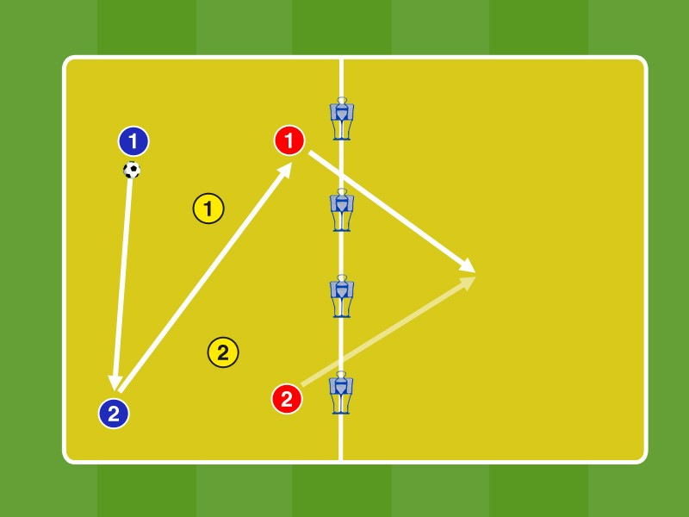In box 1 play 2 blue 2 red players against 2 yellow players in free play with no contact limit. After 5 contacts the team is allowed in possession with a pass through one of theinterfaces the dummy into the other field change by a teammate erläuft pass in the other field.

For a successful pitch-shifting the two 2's teams get the ball one point each. Make a point to get for 6 contacts in the field. The 2's team, which loses the ball goes into the defensive role, so does the R1 fault for losing possession play B1 + B2 + G1 + G2 to R1 + R2.

The player in possession to fan out in width and depth in order to record the largest possible area. They play with as few contacts and try the first contact has an open pass line find a teammate.
The ball ends are demanding by vertical walkways to another field balls to shift. The fields change to be well prepared in order to continue playing in the other field directly back in the stable possession can.

variations:
- Game with a maximum of 2 contacts
• 3 + 3 vs. 3/4 + 4 vs. 4 / ...

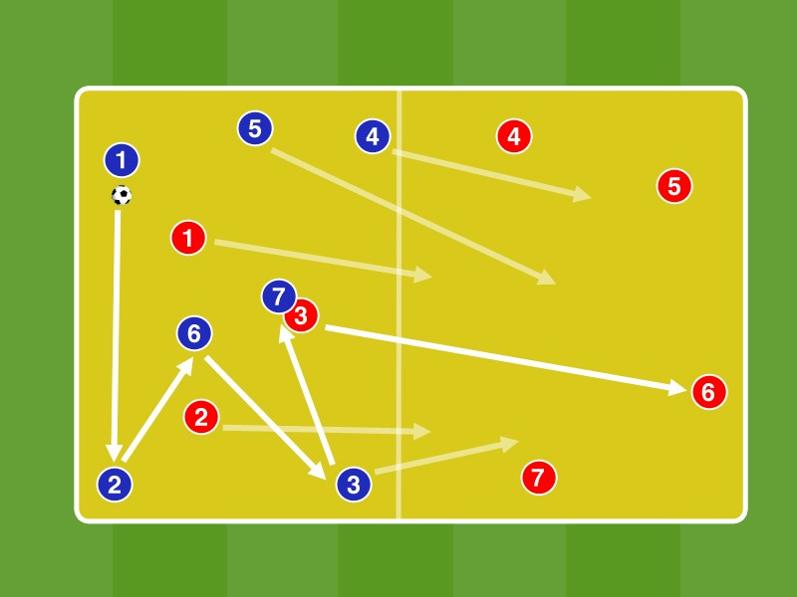A divide 25 by 15 meters large field in 2 halves.

In box 1 Blue plays with a maximum of 2 contacts in 7: 3 against Red in possession. For 7 ball contacts in a row there is a point.

Conquered red in box 1 of the ball they play on a Red in field 2. The Reds back then immediately after completely in the field. 2
From Blue 3 players may be promoted to Field 2 to Defend. The game goes in box 2 immediately in 7: 3 continues.

Blue should play in the narrow space their outnumbered ratio by fanning in space and short-passing game.
In the extremely narrowed pitch a good pre-orientation is essential for a stable possession. Players are mutually coach and try to scan pre-aligns the play situation before the pass.

In losing possession Blue switches immediatelySo yellow can not play in the other half of the ball. Succeed the fields change hunt 3 Blue immediately sprint to the ball afterwards to recapture him directly, at best, before Red has positioned with all the players again.

Variation:
6: 6 in 6: 3/5: 5 in 5: 2

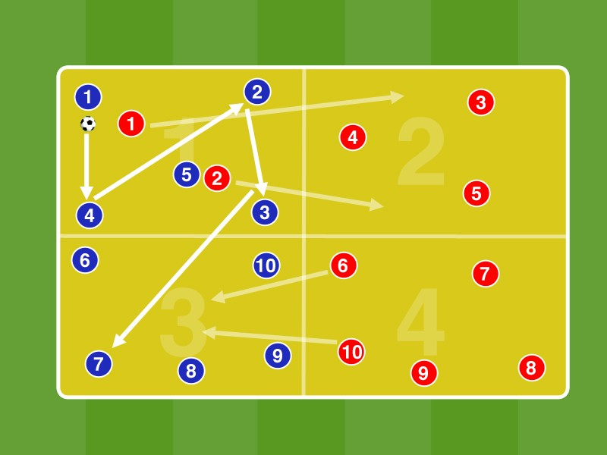An approximately 25 by 25 meters large field into 4 equal parts divide.

In box 1 5 Blue play in direct match against Red 2. After at least 5 contacts blue may change to the adjacent field 3 on the blue player.
Once the ball is in box 3, start 2 Red from field 4 to 5: 2 3. in box Both Red go from box 1 back in the field. 2
Should the Red Ball a profit (Ball Out) starts with a new red ball in diagonally opposite field (here field 4) 5: 2 vs. 2 Blue (from box 3).

For each successful (if the passport is checked in the new field) fields change the team receives one point.
Compared to 'normal' 5: 2 is added through the fields change a direction of play so that the Blues have situations must create to pass in the depth in box 1 in the ball circulation. To this end, the player should be open to the direction of play and always take the view down to pass the ball to 5 contacts directly into the box 3 can.

Variation:
If it is possible the red ball for a ball profit to fit into the diagonally opposite field (eg field 1 in field
4) Receives Red 3 extra points. Blue immediately goes into counter pressing and so tried a Herausverlagern the lane change to avoid by counter pressing.

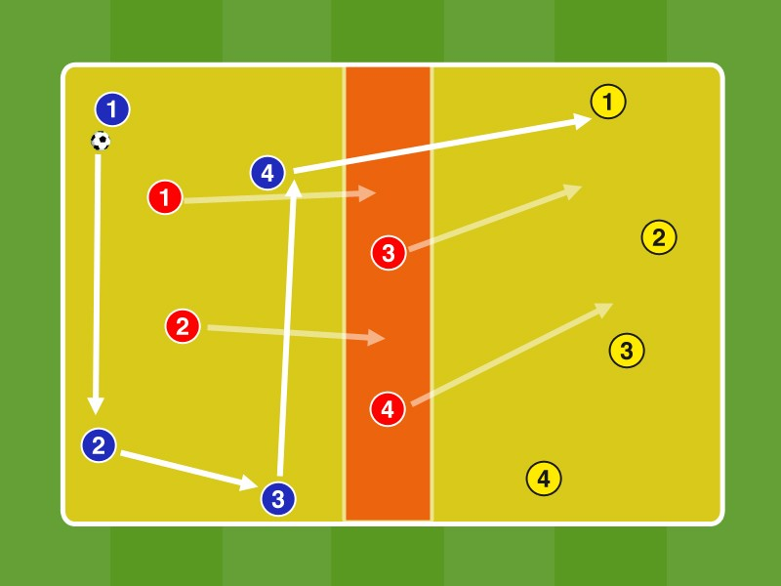In a 25 x 20 meter field a 5 meter wide central zone mark.
In box 1 Blue playing in 4: 2 against 2 red player. After 5 passes in a row blue may change to Field 2 to yellow. The two Red in the middle zone can actively defend this pass.
Succeed the field displacement push the 2 Red from the central zone in zone 2 after and play against 4 Yellow 4:. 2 The two Red from box 1 slide in the central zone.
Should the two Reds in box 1 a ball gain or catch the two Red in the middle zone the ball from Red exchanges with Blue, the objects and the game goes in box 2 with yellow against blue in 4: 2 on.
For each page, shift, there is a point for the team which played the pass to the relocation.

The Blue try through fast ball consequences, both to bring the two Reds in box 1, and the two Red in the middle zone of the running, so that there are open lines pass to the side shift. The players are oriented always forwards ( 'look into the depths!') To identify opportunities for lateral adjustment. The potential pass receiver position in the pass windows.
Play the ball in front of the side shift diagonally forward and go into the ball and be able to move with speed and to be optimally pre-oriented.

Variation:
The place a neutral player in the transition line from Field 1 and Field 2 to the central zone, which always plays in possession of the ball club and only allowed to play directly.

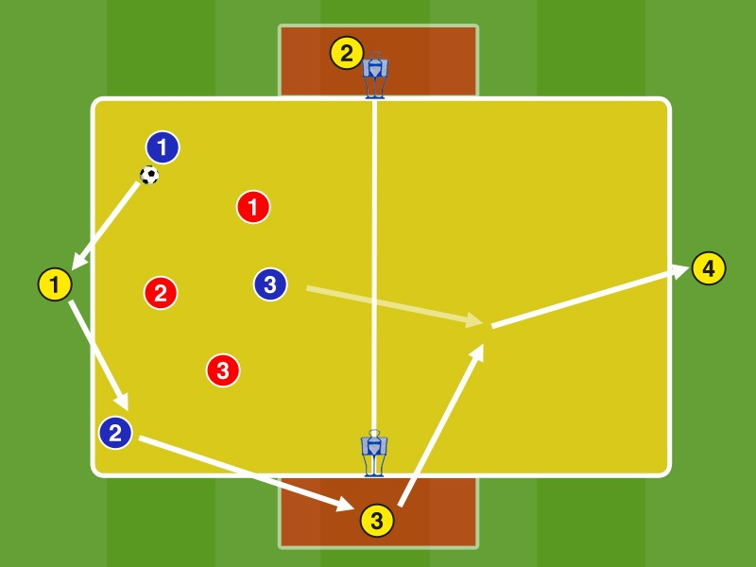Blue plays against Rot in field 1 in 3: 3 3 neutrals, where 1 Out are positioned on the baseline and 2 Neutral in small areas at the edge of the center line. After at least 5 passes in a row the team in possession may on the outer neutrals G2 and G3 move to another field. G2 and G3 have only 1 contact, they may also return to the box 1 can bounce.

For fields alternating G2 and G3 can play in Field 2 on a player possession of the ball team, or in the depth of G4, which must be then collide directly with the team in possession.

Fanning over possession while away from the border areas around the neutrals around. Immediate counter pressing with ball loss to come directly back into possession before the other team can position.
The outer neutrals G2 and G3 allude in the ball away feet, so that they can continue playing with the first contact to the other field. Pay attention to the cover shade / shortened Pass angle through the dummy.
Even before the pass on G2 or G3 is the team effort nachstarten over possession to the other field, there to call with the player. However, note that the center line is considered offside line.

Points:
1 point for 5 contacts in the field and 3 points for every field change.

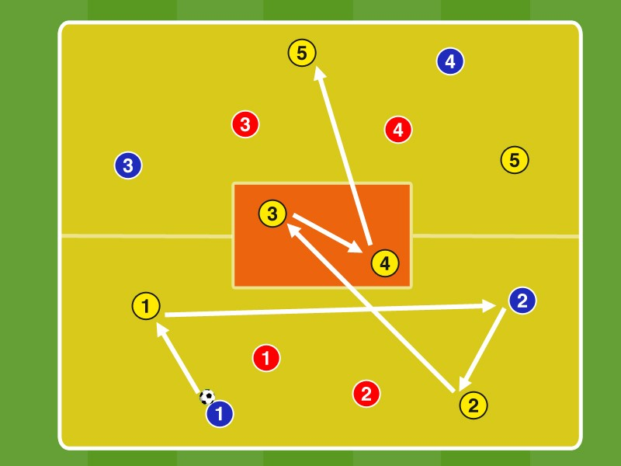A divide approximately 25 times 25 meters large field in 2 halves. In the middle of a 7 by 4 meters wide central zone mark.

In Field 1 and Field 2 are each 2 blue, 2 red and 2 yellow neutral player. In the middle zone 2 neutral yellow players are positioned. In box 1 Blue playing in 4: 2 with the two neutrals to red with a maximum of 2 contacts. After at least 5 passes in a row Blue can about the two neutrals in the central zone to change the field (1 point for each field change), 1 additional point for 8 passes in a row). G3 (or G4) has the ball on G4 (or G3) can clap, which then has to change with the first contact to the pitch.
In winning the ball from red the game goes directly with Red in possession with the neutrals Yellow further.

The team in possession fan out along with the neutral and in compliance of the central zone away to not even deliver vertical pass way for introducing the fields change.
G3 and G4 attention to a signal depth, to go to ball Gossip ball combinations the field can.
The baller waiting team will by dynamic position change and fanning her open registration lines to be playable for fields change and to be able to transition to a stable possession.

Variation:
After a field change by the middle zone of the neutral player who has played the pass to the shift changes, introduced by the neutral player of the fields change with his passport in the central zone has the position.

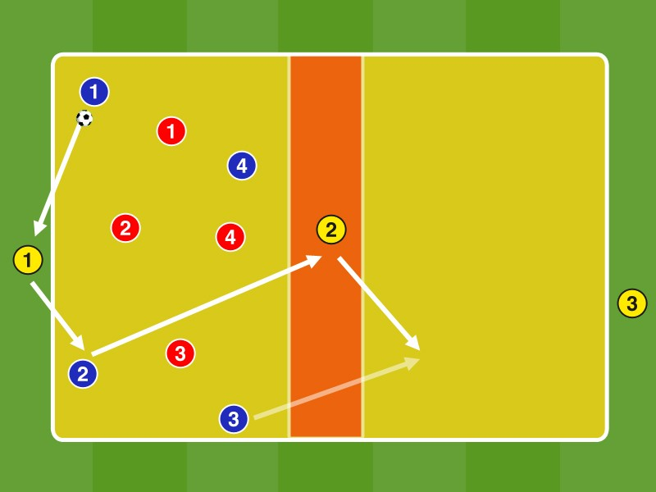In box 1 play 4 against blue 4 red player with the neutral Yellow, which are placed at the outer ends and in the central zone. Thus, it is always with 2 men outnumbered in 6 field: played. 4

Blue and red playing with 2 contacts (if the ball from the opponent comes 3 contacts), the neutral Yellow must play directly.

After 5 contacts the team may change over possession over the middle neutrals to another field. Before the ball in the middle zone is, no one may enter except the central neutral zone this. The middle Neutral can either be directly collide into another field, or play on a player possession of the ball team, which then has to continue playing directly into the other field.

The player in possession fan in width and depth in order to record the largest possible area and in compliance with the neutrals away to run different pass lines. They take special care that there is always an opponent between them and a teammate is to guarantee as to occupy custom contoured lines and pass levels.

Points:
1 point for 5 contacts in the field and 3 points for each face-off on the neutrals in the depths for a field change.

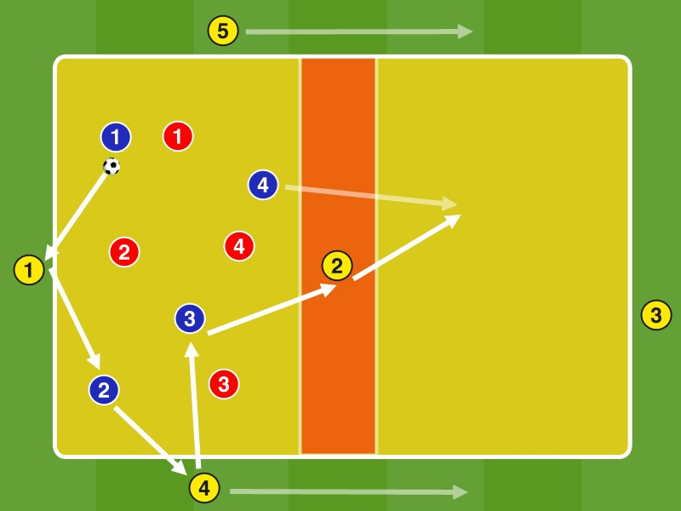As previously in 4 vs. 4 + 3N between the lines. Now two more neutral player G4 and G5 are added to the sides.

Possible locations:

G1 = TW
B1 + B2 = IV G4 + G5 = AV
B3 + B6 = Double Six, or 6 + 10 = 10 G2
G3 = tip (or TW, see G1)

The change in the other half can as before via G2, or via G4 and G5 to a fielded starting Blue, for example. With a pass from G4 to the incoming B3. The team in possession to the fields change consciously call by runs in the depth.

Points:
1 point for 5 contacts in the field and 3 points for each face-off on the neutrals in the depths for a field change.

17th 6 vs. 3 'BETWEENTHE LINES IN THE SPA '

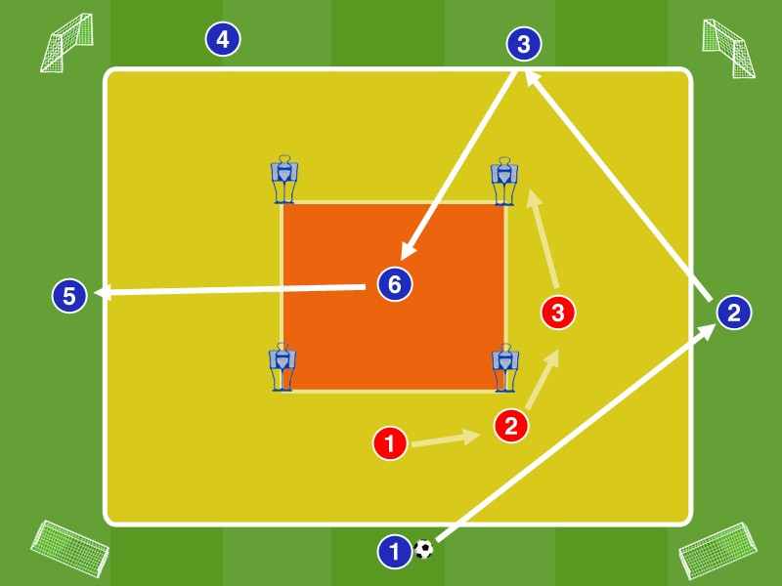Mark A about 15 by 15 meters large field. place Ministore at the corners. In the center of the yellow field limit a about 6 by 6 meters large internal field with dummies.

Blue plays in 6: 3 against Red, with 5 Blue may reside just outside of the box and a Blue (may vary) only in the center region between the dummy. The Reds are allowed to enter the middle field only when the ball is in it.

Blue scores a point in which they allude to average players and this makes the 1/2 Contact an outer Blue. Red, in winning the ball on one of the mini Goals counter (= 3 points).

Possible locations:
When SpA with triple chain: B1 + B2 + B5 = IV (or abkippender six + IV + IV when 3-structure), B6 ​​= six / B3
+ B4 = 10
When SpA back four: B3 + B4 = IV / B5 + B2 = AV / B6 = six / B1 = 10

Blue tries to come to B6 between the lines with fast, punchy passing game, while red is trying to deliver the passing lanes. In winning the ball from Red Blue immediately goes into counter pressing.

Variation:
Blue can earn points if it manages to dribble outward B6. He plays then further out, while another blue in position change the zone within the dummies busy

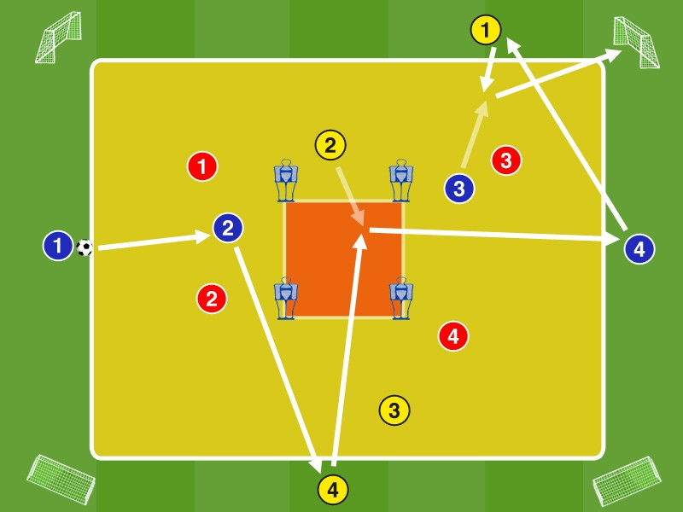Mark A 20 by 20 meters large field. In the middle of the field placed 4 dummies at a distance of about 2 meters, according to the figure. Place about 5 meters outside the corners of the playing field ever a Minitor.
Blue plays with yellow neutrals in 8: 4 against Rot, wherein each 2 Blue and 2 neutral yellow are inside and 2 outside the field. The 4 Red defend in the field.

Blue scores a point by achieving a goal in one of the 4 Ministore by at least 7 passes in a row. For an outside player must be directly impinge on an internal player, which concludes with the first contact on Minitor. In addition, Blue receives 2 points when a Blue or Yellow passes the ball within 4 dummies with the 1st / 2nd contact to a teammate.
In winning the ball fans out red and yellow playing with the 8: 4 vs. Blue, with 2 red the wing of B1 and B4 and 2 Red occupying positions in the field.

Blue tries to bring the Reds into a run with fast, punchy passing game. They are superimposed on the ball-related areas in order to achieve either goals through direct pass-combinations, or to herausverlagern on isolated ball away players from the compressions out. They are trained to pay special attention to opportunities to diagonal displacements.

Blue scanned this field in order to detect the opening of the outer focusing pass lines through the center in the red zone between the dummies.

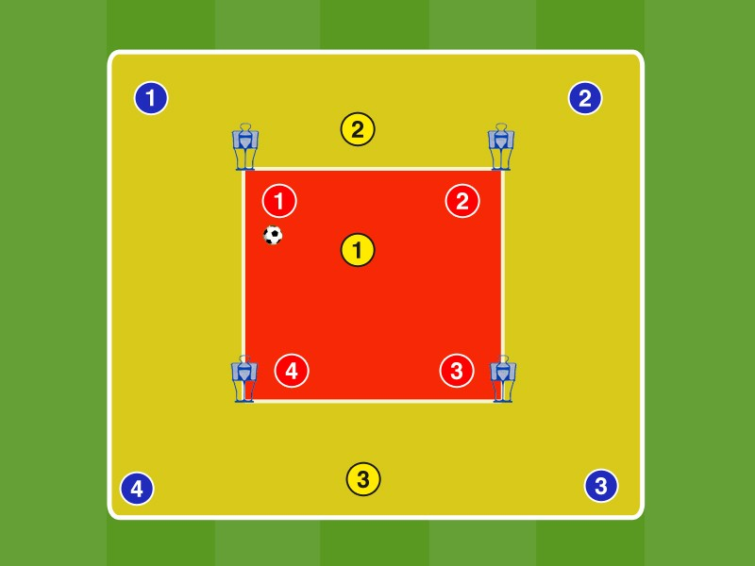Mark A about 25 by 25 meters large yellow box. This limit an approximately 8 x 8 meter big red box with dummies.

In the red box Play 4 Red to G1 in the 4: 1 in direct game. Outside the red field 4 blue and 2 yellow players are positioned in the yellow field. If we succeed G1 in red box to win the ball, or leaves the ball on the red zone, play in the complete field 4 Blue with G2 and G3 in 6: 4 against 4 Red.

G1 remains in the red inner field. The aim of the Blue and Yellow is fit to G1 in red box. The aim of the Red is for a ball win in the yellow field also a play on G1.

Points: 10 passes in the red zone = 1 point / 10 passes in the yellow field = 1 point / pass from the yellow box in the red zone on G1 = 3 points
change: After a pass to G1 from yellow to red field change red and blue positions

Red goes for a ball lost in the 4: 1 immediately to counter pressing to as quickly as possible to win the ball back. However, you have to defend in the red zone on G1 particularly the passing lanes between the lines.
Blue is positioning itself as in the yellow box to the one to be close to the red box to balls to be able to have just in from intercept, on the other, on the go from fanning to be positioned optimally for a ball win to in a stable possession to proceed with options to pass to the Red box to G1.

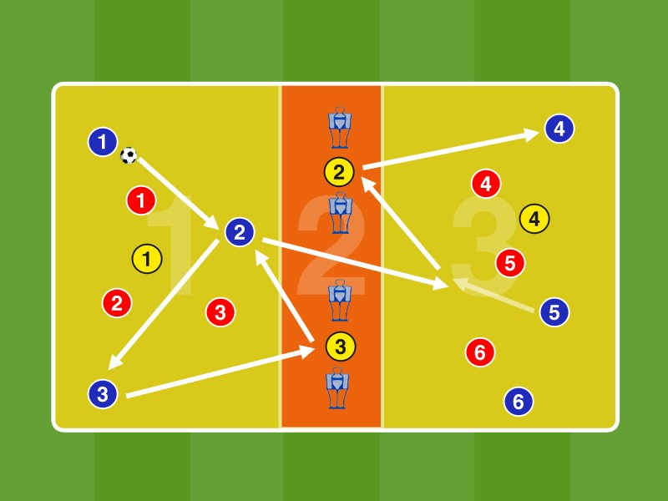Mark A 30 by 20 meters large field and divide in the middle by an approximately 5 meter wide central zone.

In Field 1 and Field 3 respectively 3 blue and 3 red player, and a yellow Out are positioned in the central zone located between the 4 dummies 2 yellow Neutral.

Blue plays in box 1 with 3 yellow neutrals in 6:. 3 After at least 5 passes in a row can be changed to a teammate in the field. 3

Pro fields change 1 point.

Blue is positioning itself in zone 3 so that it in the depth of one of the two neutrals can collide in the central zone by a abkippenden free man passes, to best fit then directly deep on another player can.
The two middle neutrals orient the right to thereby scan the opposite field in the depth can. Choose constantly aware between which dummy positioning themselves to the one to stand in open registration lines, but on the other hand, above all, to open pass lines in zone 3 and perfectly blank to bounce to be positioned.

Variants:
The fields change must not be identified by a yellow neutrals
Game with 2 contacts, the first contact after the fields must be changed directly

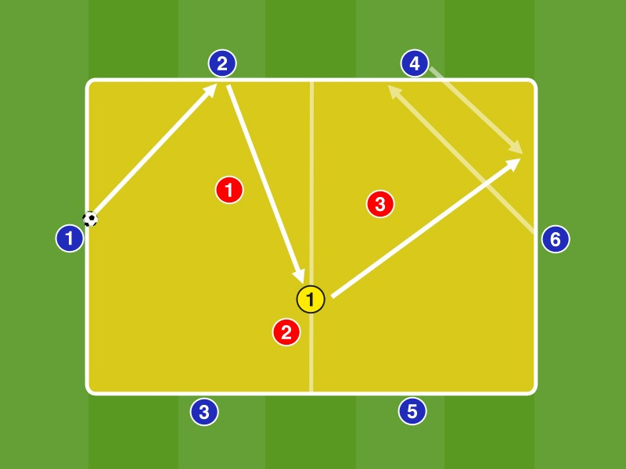Mark A about 25 by 15 meters large field.

Blue plays the field with a yellow in 7: 3 against Red The yellow may move freely in the field, while the 6 Blue may move only along their respective sidelines..

The goal is to play on G1 in the depth, in front of a pass in the depth of the Blue on the front side (here B6) with another Blue necessary to change the position.
Points: Red earns 1 point for 7 contacts the Blue and -2 points for a pass from blue to G1 to another Blue.
Replace the 3 Red After 1 minute.

G1 is positioning itself as a free man again in the interfaces between the lines of 3 Red to be playable. The Reds are particularly noted this pass to G1, but also need to focus on the passes on the wing.

With a pass on G1 B6 pulls away from his position to abkippend to demand the ball from G1. B4 (or B5) runs against the same in the drawn-free area, either to be alluded to in the depth directly or in the game on the third.

variantallow passports from G1 into the depths without position change:

22 7 vs. 2 MEDIUM PASS TRIANGLE 'PASS ON A LINE'

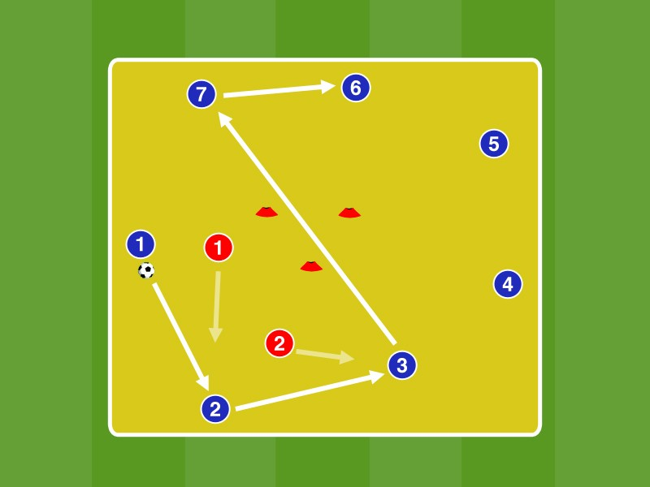Mark a 9 by 9 meters large field. position in the middle 3 cones in a triangle, a distance of about 1 meter.

Direct Match 7: 2, where a pass 5 additional contacts one by the hat-triangle. At 20 contacts = extra round

Blue tries with fast, punchy passing game to bring the Reds into running that create passing lanes through the center.
Priorities possession of the ball team:
- circulate the ball outside, to be opened inside pass lines à Outside focusing to pass the lines open center
- interfaces Open by quick ball circulation in the position game

Variation:
A player in the middle position, can be played over the.

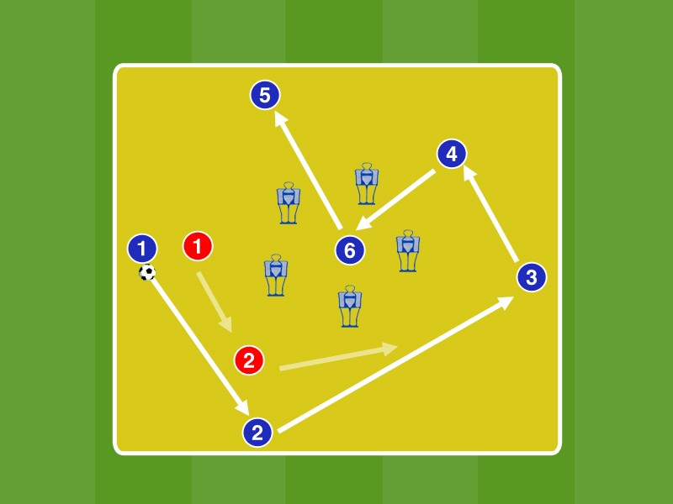Mark a 9 by 9 meters large field. position in the middle dummies in a pentagon, a distance of about 1 meter.

Blue plays in 5: 2 against Rot, wherein an additional blue blue players between the dummies positioned.

Blue scores a point by pass in the zone between the dummy and the media player succeeds directly to the first contact to play a winger.

Points count after 1 minute to replace the red player.

Blue tries with fast, punchy passing game to bring the Reds into running that create passing lanes through the center. Priorities possession of the ball team:
- circulate the ball outside, to be opened inside pass lines à Outside focusing to pass the lines open center
- interfaces Open by quick ball circulation in the position game variation:
• 6 + 1 vs. 2
- not occupy the center. It needs to be broken a Blue with a pass in the middle zone to score a point.

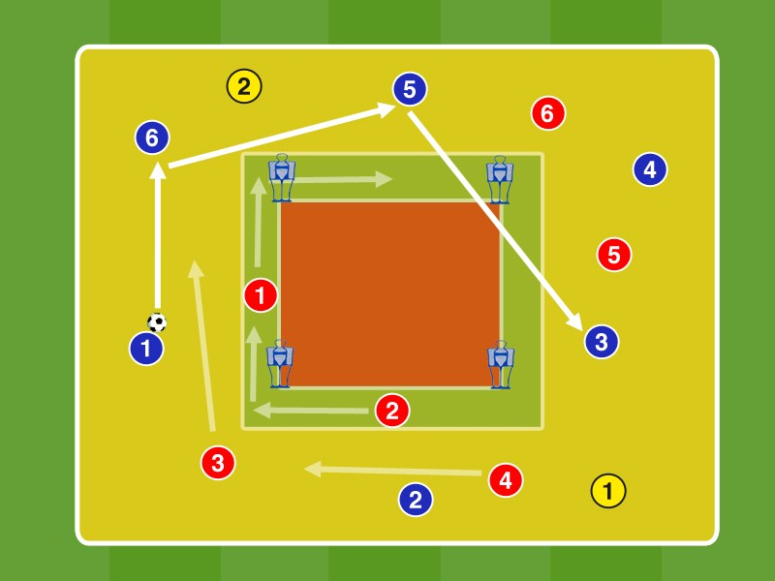A field of size 25 by 20 meters mark. An inner limit red 5 times 5 meter zone with dummies. another 2 meter wide green zone Around it marked.

Blue plays in the yellow field with 2 yellow neutrals in 8: 4 vs. Red 2 Red more occupy the green narrow face.. You are permitted to reside only in this green zone.

Blue can score a point by pass 2 side lines of the red zone. Red tried this defend and can for a BG by Eindribbeln in the red zone to win the right of attack. In this case occupy 2 Blue green zone and red playing with yellow in 8: 4 in the yellow field.
Blue tried through fast ball combinations together with the two neutrals pass window to open by the dummies over 2 lines. The 4 outer Red seek through ball oriented shifting together with the two inner Red closing the passing lanes.

Points:
- Point 7 contacts within the field
- Points for a pass diagonally through the dummy lines to a teammate 3 points for a vertical pass through 2 dummy lines to a teammate Variation:
Position another neutral games in the center between the dummies on the (between the lines)
is played.

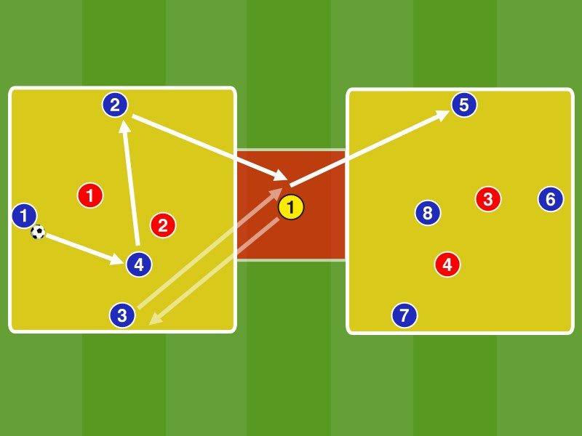Mark Two approximately 16 by 16 meters large fields. In between, an approximately 5 by 5 meters wide intermediate zone.

Blue plays in box 1 in 4: 2 against Rot, wherein B1, B2 and B3 are each positioned around its sidelines while B4 occupied the center.
The aim is to change to a blue box 2 over the center field G1. The exchange should / can be activated by a blue in the red zone means that changes the position with G1.

Points: 1 point for red per pass on G1 + 1 point for red fields per change

After 90 seconds, 4 red Replace with 4 blue players.
If G1 is not playable, he is to leave his position in the central zone (between the lines) in the dynamic position change and are taking this position in a blue against same free drawing.

By leaving the central zone of the two G1 Red must decide whether to focus additionally defend against G1 in the field, or to focus on the same route against a blue in the red zone means to prevent the fields change.

variant: Remove one blue and one red per pitch half away, so that in each case a 3: 1+ 1 arises

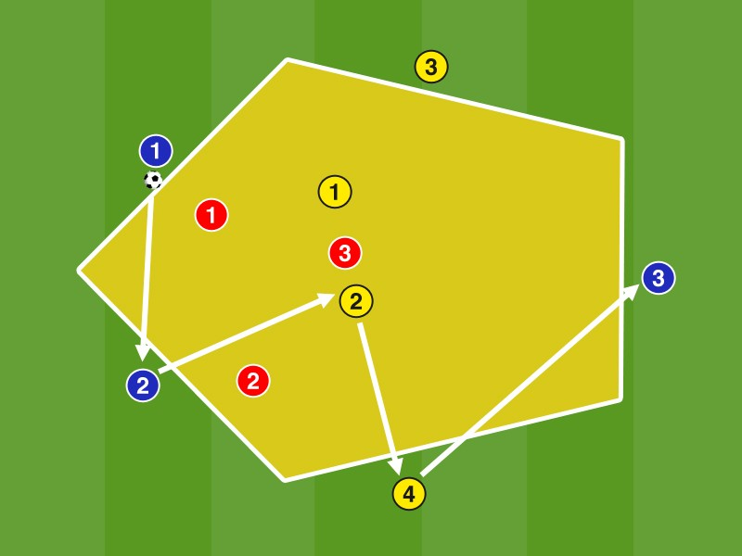Mark A pentagon with side length of B1 and B2 is about 10 meters, the side length of G3 and G4 about 12 meters and the B3 of about 8 meters.

Blue plays along with the yellow neutrals in 7: 3 against Red Red Conquered the ball they fan the positions of the blue and play with yellow against blue which then defend inside the box..

The goal is to play the ball over the middle two neutrals G1 and G2.

positions:
Points:
Each pass on G1 and G2 is worth 1 point for the team in possession of ball. 8 passes in a row = 3 points

B1 + B2 = IV / G1 + G2 = double six, six or +10, respectively. Six and engaged AV / G3 + G4 = AV / B3 = Ten

The Blue in possession trying through dynamic passing game the Reds so to get into a run that pass lines open into the center on G1 and G2. Paying careful attention on diagonal lines pass to Rausverlagern.

Red defends the ball into the center lines on G1 and G2, but has to also pass the lines on the outer G3 and G4 and in the vertical on B3 oath. You must ensure together build the largest possible coverage shade to share close contoured lines can.

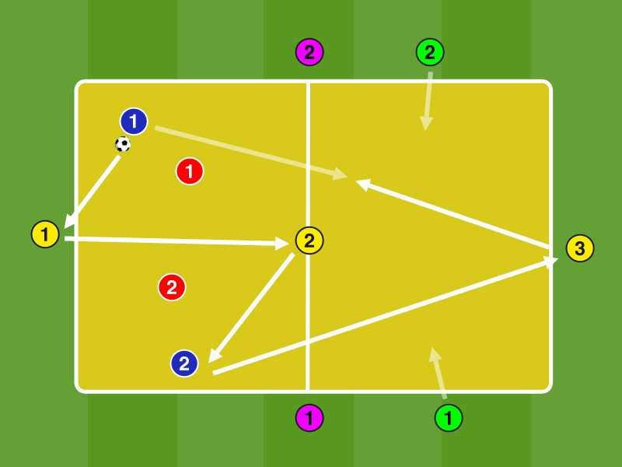In box 1 2 Blue play against 2 Red with G1 and G2, which move on the lines in 4: 2 with 2 contacts (the neutrals directly). After 5 passes blue may change to G3 to another field.

In box 2 then plays B1 and B2 with G2 and G2 against GR1 and GR2.

If R1 and R2 manages to win the ball in field 1 (to dribble through the external line or to play another player) they break and P1 and P2 come with ball into the box and playing in 4: 2 against blue. The same goes for GR1 and GR1 in winning the ball in the other field.

By 5 different colors to match the form is very complex, so that constantly new pairings occur. The two players in possession to try to span a large area together with the two neutrals and find open registration lines for the pass into the depths to 5 contacts.

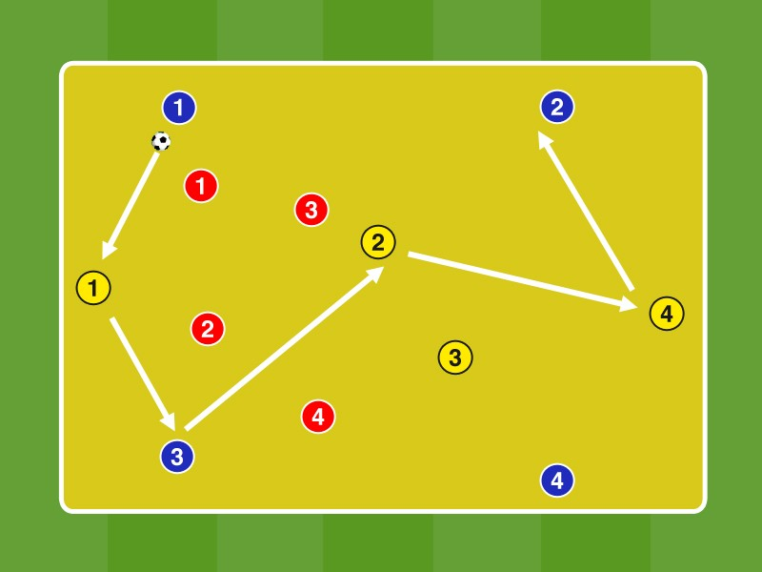Blue plays with yellow in 8: 4 vs. Red with a maximum of 2 contacts. With 8 contacts in a row there is a point for both teams over possession.

In winning the ball from the red team that has lost the ball goes into the role of the ball conquerors. The ball is considered but only as conquered if yellow has fitted the ball obtained in a teammate. The team in possession has thus the chance in direct counter pressing reclaim the ball.

Through the direct exchange after losing possession constantly emerging game situations. The ball ends are to fan out in the game with the ball in order to play on a large area and must also occupy the center in order to make best possible fit triangles can. With the 1st contact is directly open to a teammate pass a line to have good angle for the next pass.

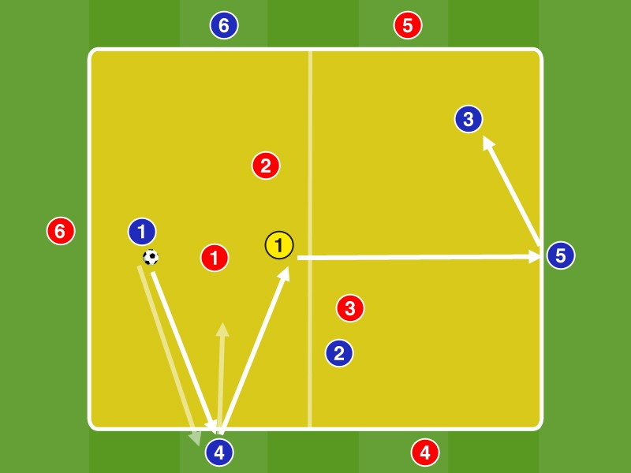Mark A 20 by 20 meters large field.

Blue plays the field in 3: 3 against Red, both blue and red respectively 3 player has positioned outside of the field. In the center there is an additional Plain.

Blue plays with the neutrals in 7: 3 against Red in possession.

After each pass, a blue player on a Blue outward change these two players the positions.

The Blue are trying to constantly open up dynamic new passing lanes by the position change for a pass to the outside. It is the external Incoming previously scan the field to dynamically detect recordable rooms.
The Reds are trying to isolate the Blues in a playing area by jointly defending and exploiting the cover shadow. Defend deliberately not playing against the player externally, but take the player on, coming from the outside (see FIG. Doppelpass error).

Variation:
- Game with 2 contacts, external players and Plain directly

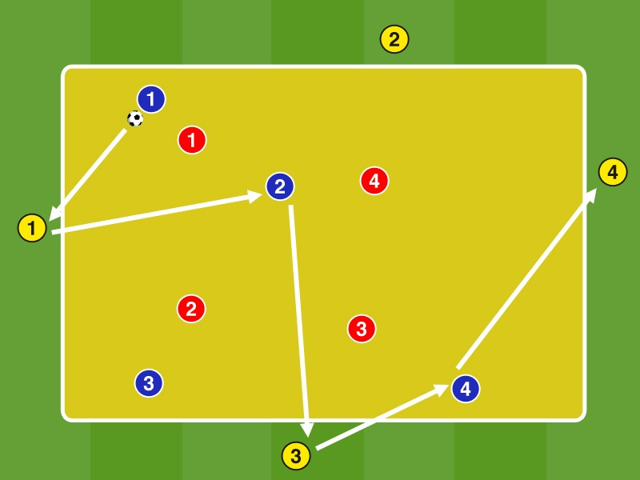In field play 4 against blue 4 red players in free play with 4 neutral Yellow, staying on the sidelines and are always with the team in possession. 8 passes in a row count as profit point. If it is possible to play in a move involving the neutrals in the depth (G1 and G4), there is an additional 3 points.

The Blue in possession fan out, occupy the possibility the center and stay away from the neutral players on the sides to form an optimal network with many pass triangles. Position change ( 'Give & Go') after the pass to create new situations and to bring so dynamic into play.

Players should always prefer the game in depth at G1 and G4 pure possession.

Variation:
The neutral outside player change after each ball contact the position with a neutral neighbor, so even emerge more dynamic game situations.

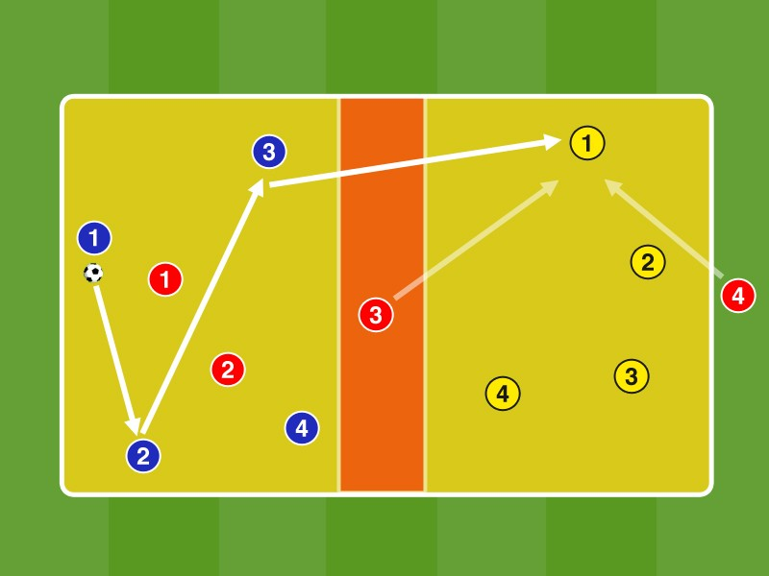A divide 25 by 20 meters large field in 2 halves and mark in the middle of a 3 meters wide central zone.

In box 1 4 blue player play in 4: 2 against Rot R3 is positioned in the central zone, R4 on the other side behind the field..
After at least 4 passes blue must beware yellow in field. 2 R3 in the central zone must actively defend this pass. Once the ball enters the field 2, R3 and R4 defend against yellow. R1 occupies the position outside the field, R2, the central zone.

The team that loses the ball (ball out of bounds, or 2 contacts the opposing team), changes in the role of red.
The 4 ball ends Blue to fan out clearly to span a maximum area. Try by punchy passing both R1 and R2 in the field and especially to ring and R3 in the central zone in the running to open registration lines for fields change.

The Yellow position themselves in the currently open registration lines and paying attention that they are optimally pre-oriented. This is essential, since they get directly to the ball in their field from both levels (of R3 and R4) pressure. R4 anticipates the pass (also depending on the coverage of shadow R3) to fields alternating and positioned behind the box so to as soon as possible together with R3 access to gain on the ball.

Variants: 5 + 5: 2 + 1 + 1, 6 + 6: 2 + 2 (2 in the central zone) +1 / ...

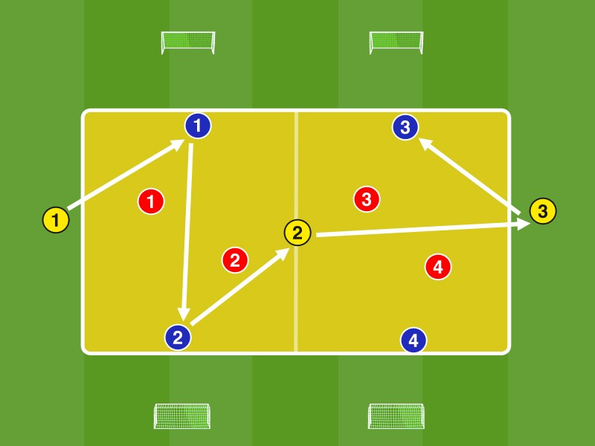Mark A about 25 by 20 meters large field. Outside of the field, about 8 meters from the sidelines place 4 Ministore.

Blue plays in box 1 in 4: 2 with G1 and G2 against Rot in Field 2 2 more blue and 2 red and a yellow Out on the front side are positioned.. The aim is to change over the central neutral G2 to another field.

Captured Red the ball passes the ball conqueror over a line against a Blue in 1: 1 on a Minitor. The Blue should not defend behind the line here.
Blue scores one point for 8 contacts and 3 extra points for combinations of G1 through G3 back to G1 (, ping-pong '). Red earns 3 points for a goal.

Blue fans out in ball far and in compliance with the neutral Yellow remotely to span the widest possible net.

By fanning out and the resulting outer focusing registration lines open to the free man G2 at the center, which should be actively sought from the possession takes team. Fanning is also necessary in this rondo form in order for a loss of the ball each line in 1: 1 to defend optimally.

positions: G1 = IV / B1 + B2 = AV / G2 = six / ...

Variant: Blue which may also switch directly to B3, B4, or G3 to the pitch.

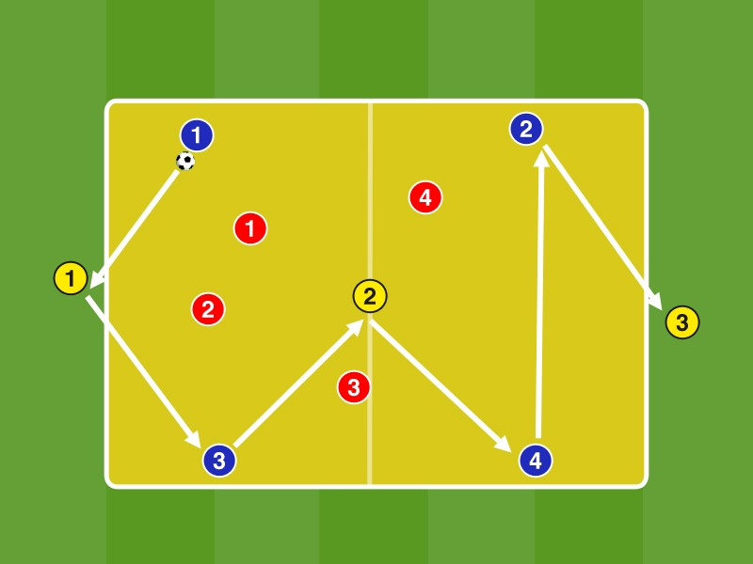Marking an approximately 26 times 13 meters large field.

Blue plays the field in 7: 4 with 3 neutral Yellow to Red 2 Yellow are positioned at the end faces, one in the field..

Blue scores one point for 8 contacts and 3 extra points for combinations of G1 through G3 back to G1 (, ping-pong ').

positions:
G1 = IV / G2 = six / G3 = tip, or tens B1 + B3 = AV, or IV in 3 chain
R1 + R2 = Forward

Blue fans out in ball far and in compliance with the neutral Yellow remotely to span the widest possible net.
By fanning out and the resulting outer focusing registration lines open to the free man G2 between the lines, which should be actively sought from the possession takes team. The middle Neutral scans the pitch to optimally pre-oriented to be. He keeps always aware of the vertical pass into the depths to G3 in the eye, either directly or via a third Blue.
B1 and B3 can also directly on G3 play in the depth (see. Cross-ball in the half-track), this move B2 and B4 and overloaded the center, so that Red must defend the center.
The Reds defend from the inside out and then fan after winning the ball immediately, to pass into a stable possession can. Blue goes losing possession immediately to counter pressing.

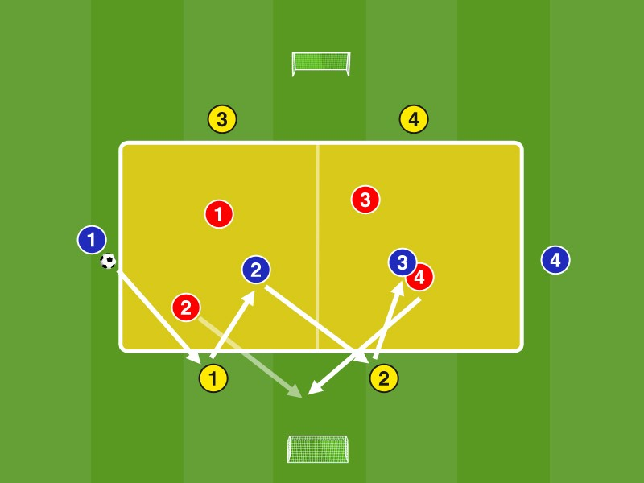up 2 Ministore a distance of about 60 meters. In between, in the middle of a mark about 30 by 20 meters large field.
The 4 blue, positioned on the edge of the highlighted field play in 8: 4 with 4 Yellow to Red 4. The internal Blue have 2 contacts the outer blue and yellow have 4 play directly. For 7 consecutive passes get blue and yellow one point each.

If it is possible the 4 Red to win the ball, they play on one of the two mini goals. You need to resize from within the field a player who enters the space behind the field. This may then conclude the Minitor. For every goal the Reds get 3 points.

The two middle Blue should accrue vertically and horizontally different registration lines in possession by diametrically opposed running movements and form possible pass triangles with the external players. They should be of the edge regions, which occupy the outer players away.
In losing possession blue and yellow immediately go counter pressing and try the ball immediately retake. You may touch it / take the ball only in the yellow field. The field marks are the counterattack as offside line.

Variant.: Game in positions (varies depending on the game system):
G1 + G2 / G3 + G4 = IV
B1 + B4 = AV, or ÄMF player
B2 + B3 = Double Six, or 6 and 10

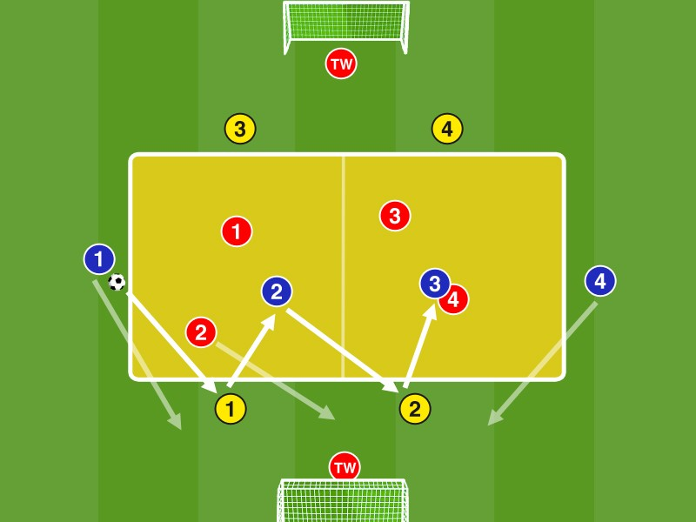up 2 goals at a distance of about 70 meters. In between, in the middle of a mark about 30 by 20 meters large field.
The 2 Blue at the edge of the field to play along with the 2 blue field and the 4 Yellow, which are outside of the field in 8: 4 vs. Red.
If it is possible the 4 Red to win the ball, play 2 of 4 Red together with the two outer Blue B1 and B4 in the 4: 2 against 2 Yellow on their line until Torabschluss in 4:. 2 On which goal they play, they can freely choose.
they achieve a goal to change the 4 Red tasks with 4 Yellow. If no goals are the responsibilities remain unchanged. The game will restart in the yellow marked field.

The two Blue B2 and B3 in the field should be both vertically and horizontally to equal to each other
offer to run different pass lines and thereby away from the foreign players.
The red team is to decide directly with the ball profit, which goal is the highest chance of a successful Pits. For a constant scanning of the playing field is necessary. A Red should always run between the two yellow IV to call the pass and to bind the two in the center of the inlet ends B1 and B4.
positions (Varies depending on the game system):
G1 + G2 / G3 + G4 = IV
B1 + B4 = AV, or ÄMF player
B2 + B3 = Double Six, or 6 and 10

- 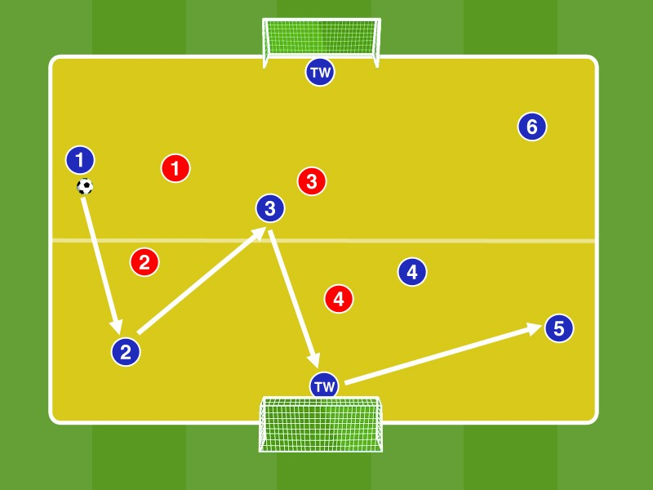Gates set at a distance of a double 16-meter space and cut the pitch in width between 16 yard box and 5-yard box.

The 6 Blue playing with the two TW against 4 Red on possession.

For 8 passes resulted in the Blues get 1 point. Conquer the yellow of the ball, they try as quickly as possible on one of the two goals to complete (per scoring a point).

The 6 Blue switch to immediately and try as soon as possible to recover the ball in the counter pressing.

The blue team is trying to play off the numerical majority with the gatekeepers in stable possession. For this purpose they fan out wide and create by occupying the center always new passport triangles.
By quickly passing game with as few contacts Blue is trying to give the yellow no access. In losing possession Blue to recover the ball immediately in the counter pressing, so immediately move the team in the highest composite pace towards the ball while the opponent orientation not lose sight of ( '1-contact zone !!')

variations:
- In the Yellow another player must touch the ball before a goal can be achieved after winning the ball.
- The scoring of the Yellow must be in the other half of the pitch, the ball conquest.

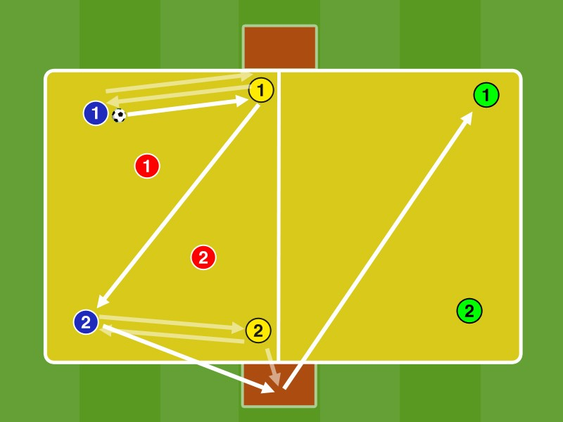A 20 ml 10-meter field in 2 halves divide. At the center lines 2 about 4 by 2 meters large red areas mark.

In box 1 Blue plays with yellow in the 4: 2 against red with a maximum of 2 contacts. The aim is to change after at least 5 contacts via G1 or G2 in field 2 to green. These may G1 or G2 leave the field easy to play from open position with the 1st or 2nd contact to another field further.

Succeed the page change to another field to green change blue with yellow positions. Blue plays in field 2 in 4: 2 with green against red on.
Captured Red the ball they change to the team that made the mistake.

G1 and G2 may easily settle on the halfway line outside the field in the red zone to the ball in
Open position to be able to play on GR1 or GR2 in depth.

R1 / R2 should be doing but solve late to be playing in the moment of release from the cover shade. They must be no longer than up to 1 second stop in the red zone.

FROM 7 vs. 3 TO SHIFT IN 10 vs. 7 IN 2 FIELDS

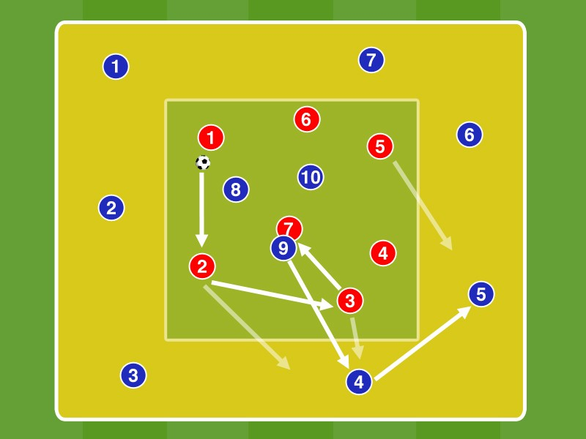A pitch of the size mark 25 by 20 meters. In it a small 15 by 15 meters large field.

In the small inner box playing 7 Red Blue against 3 players in free play with no contact limit. In winning the ball 3 Blue play this out into the big field on the blue players where the game in 10: 7 continues.

Red palms the ball away to retake and to play back into the inner box. Red succeed there, another pass pauses the game short and red stars in the small inner field again in 7: 3 vs. Blue on.

The blue team to fan out at winning the ball from the compression out in the large area and thus produce the change of the game against the ball (compression) to play with the ball (Fanning). Here blue will also occupy the center to create optimal fit angle in triangles. With passports centers increased caution, since red can come directly from a ball in possession.

With ball loss Blue should immediately go to the counter pressing to the Red 7 on return: 3 to prevent the inner box.

variations:
From 5: 2 to 8: 5 from 6: 3 to 9: 6, ...

2 MAL 4 vs. 2 + MIDDLE 1N 'SHOULDER VIEW'

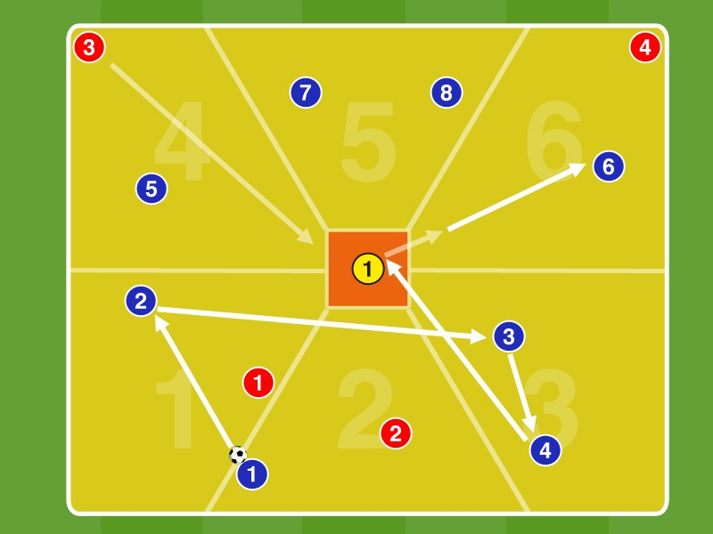A divide 20 by 20 meters large field according to the illustration in 6 subfields. In the pitch-center a small 3 by 3 meters wide central zone mark.
In the fields 4 - 6 are also 4 blue players, where 1 Blue Box 4, 2 Blue Box 5 and 1 Blue are positioned in the field. 6 There is 1 each Red at the corners of the field and 4 field. 6
Blue plays in the fields 1 - 3 of 4: 2 with 2 contacts against Rot After at least 4 passes in a row Blue should change over the yellow player G1über the small central zone in the opposite 3 fields, wherein G1 and a maximum of 2 contacts has.. Once the red player is G1 alluded starts a yellow player from its vertex (consultation of the Yellow, which of the two!) In direction G1 to defend against him and blue.

G1 has either left or right to take (4 in field) (in box 6) out of its box and out within this field with the 2nd contact B5 (Box 4) or B6 (in box 6 of the ball with the first contact ) match, then the 4: 2 in the fields 4 - makes. 6
B1 - B4 occupy while field 2 with 2 and Field 1 and Field 3 with one player, while R1 and R2 occupy the corners of the field. Captured Red the ball, they score with a pass on G1. Blue is intended to go directly to the counter pressing. After several passages, the positions of the players exchange.
G1 has preorienting with shoulder look into the depths, to see which side (R3 or R4) he gets opponents to pressure the ball in his narrow field. If he opts for the ball driving in the direction of the enemy pressure, it has to fit on a teammate with direct enemy pressure, thus increasing the risk of ball loss in this field.

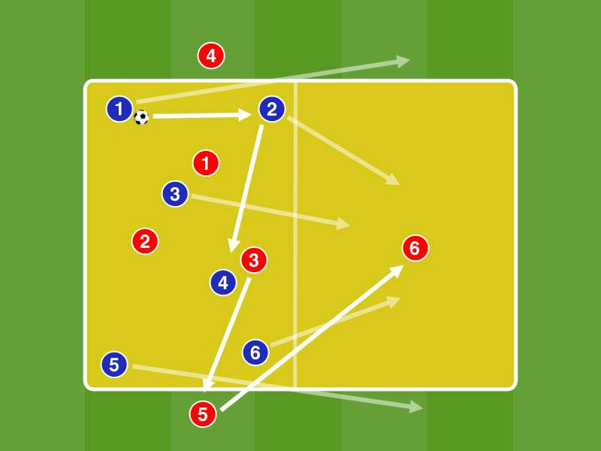A divide 25 by 15 meters large field in 2 halves.

In box 1 Blue plays in 6: 3 against Red in possession. 2 Red are positioned on the side lines of field 1, while R6 is positioned in the field. 2

Blue scores for 7 consecutive passes a point. Captured Red the ball they can shift to R4 and R5 R6 in field. 2 Red moves completely in 2. 3 Blue box defend. 3: 6 against Red 2 Blue occupy the sidelines of field 2, while another remains in Field 1.

Blue tried by rapid contacts to score points and drill it and to create by the occupation of the center pass triangles.

After a ball loss blue immediately goes into counter pressing to prevent Herausverlagern of red. They immediately put pressure on the ball and make it the registration lines to R4 and R5 to.

The outer two Red R4 and R5 sure to be playable at the ball profit of R1, R2 and R3 to Herausverlagern. They fit for their position constantly to tilt and possibly from too shallow to find open registration lines.

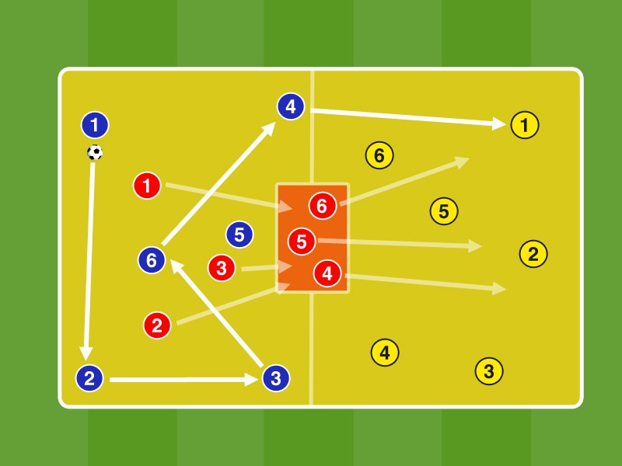A divide 25 by 15 meters large field in 2 halves. In the middle of an approximately 3 times 2 small zone mark.
In box 1 Blue plays with a maximum of 2 contacts in 6: 3 against Red in possession. After 7 passes in a row blue can in box 2 change to yellow (= 1 point). Succeed the fields change, move the 3 Red to Defend in box 2 and play there against yellow in 6: 3 on. The 3 Red from box 1 back into middle small box.

Conquered red in box 1 of the ball they can score a point by a ball on one of the Red in the small box.
With loss of possession of the Blue coach plays the ball on yellow. 3 Blue hunt in the field 2, while the other 3 occupied the central panel. Red occupied 1 box.
The team in possession tries by rapid contacts to score points and drill it and to create by the occupation of the center pass triangles.

In losing possession Blue switches immediately so red can not play in the red field the ball. Succeed the fields change hunt 3 Red immediately sprint to the ball afterwards to conquer him in the field. 2 The same applies to blue at a loss of the ball in box 1. They defend aggressively forward on the ball and close by exploiting the cover shade possible passing lanes.

Variation:
7: 7 in 7: 3/7: / in 7: 4/5: 5 in 5: 2/4: 4 in 4: 2 / ...

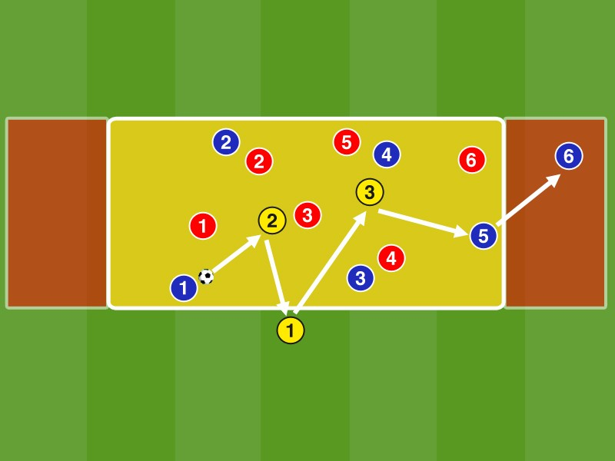Mark A 30 by 15 meters large field. On the sides additionally 2 each 5 x 15 meter red zones.

Blue plays with yellow neutrals in 9: 6 against Rot, where 2 Neutral playing field and a neutral outside the field.

The field is played with a maximum of 3 contacts the outer Neutral has max. 2 contacts. The goal is to play in the red outer zones and move from there to the opposite outer zone.

- Points for a change of an outer zone to another. 1 point for 7 contacts in the field.

G1 is occupied by a central six, on the outside can be displaced over the rear diagonal at a compaction in the yellow field. The displacements may also occur with high balls. It is to be aware of shifts with few contacts to play from the overcharging out on a (at best isolated) players in the ball away outer zone.
Not directly move back from the outer zone out again, but there only play contacts until the opposing team is vorschoben again, to then switch to the shifting direction again in the opposite outer zone can.

Variants:
7: 7 + 3N / 8: 8 + 3N / ...

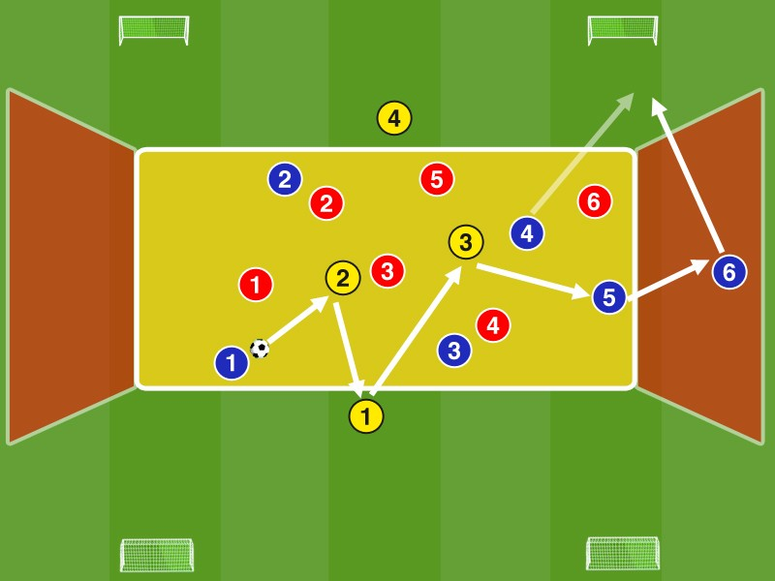As previously in the '6: 6 + 3N in the half-track'

Now can be fitted into the space behind it for a pass in the outer zones from there to score a hit on one of the 4 mini goals.

Players may leave the field (yellow + red zones) until the ball leaves the field. The yellow box markings are assumed to be offside line.

Points:
1 point for 7 contacts in the field
Game shift from an outer zone to the other = 2 points
Goal = 3 points
The Blue are in possession together with the yellow neutrals consciously page overloaded to add lure the Red there and then player isolate on the opposite side and this by dynamic displacements, also aware of the external neutral G1 and G4 (position: central Six) to be able to allude. From the outer tracks to be played in the half-track towards Minitor an inlet ends out of the field in the cross-ball. Red can (should) after the pass defense even outside the field. If no scoring be able to choose to blue so positioning (tipping behind the ball / counter-assurance) that a way back into the open country (see. Away games of the chain) is possible in order to score points there through contacts or to relocate again.

Variants:
- Game with Game direction (blue and red assign each 2 Ministore)
- Set up a mid-goal at which to 7 contacts in the yellow field, a goal can be scored through the center.

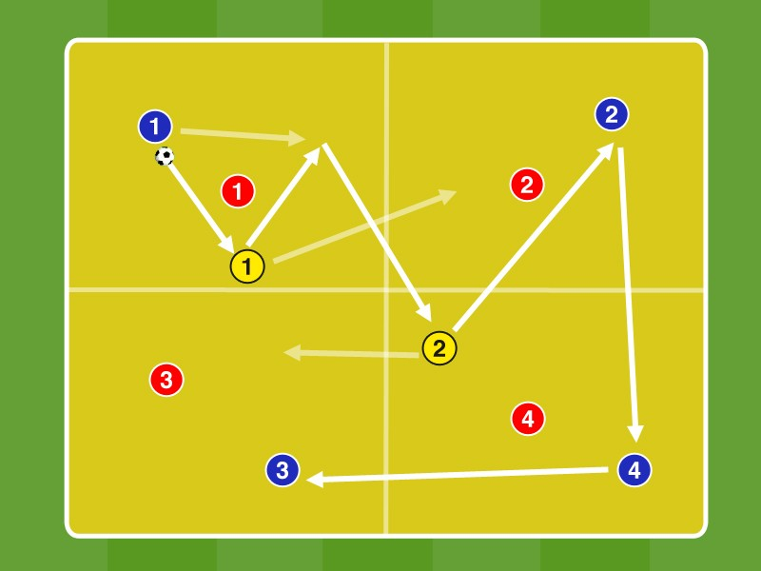A divide approximately 28 times 18 meters large fields into 4 equal areas.

Blue plays the entire field in the 4: 4 with 2 additional neutrals against red, the 4 Blue and Red 4 are allowed to move only in their respective subfields. The two neutral Yellow may move freely in the entire field,

Points:
  - Pro-recorded field (= pro fields change) 1 point
  - All 4 fields recorded without loss of ball = 3 additional points

The yellow neutrals support as a free man in each case the field in possession of 2: 1 and anticipate that field may be recorded in fields change in order to also a 2: 1-establish outnumbered.

Through their freewheeling behavior make the Blue together with the two Yellow-two situation forth to the 2: prepare against Rot game situations to change fields. 1 The blue players who are in the field without the ball running in the same against cutting with G1 or G2 so freely that they occupy different pass lines

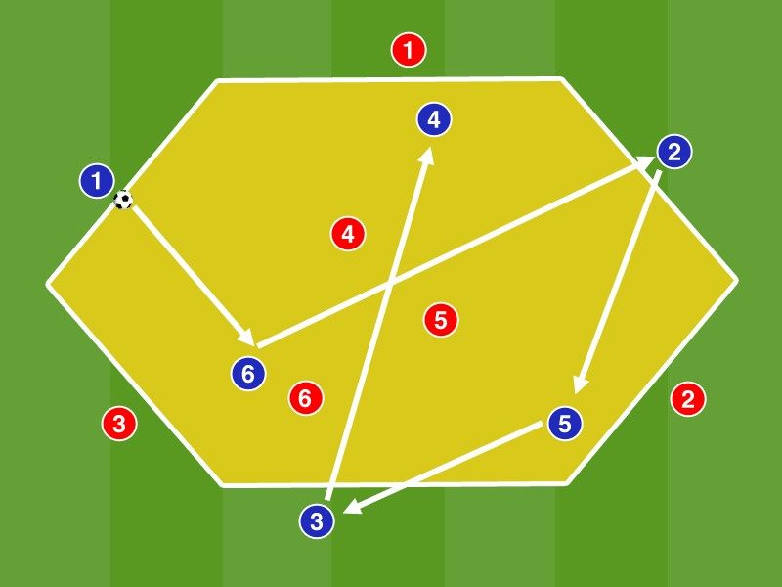Mark A hexagon with edge length of about 8 meters.

In field playing 3 Blue 3 against Red. Outside of the field each 3 more players are positioned on the side lines, always a Blue is next to a Red.

Blue plays in a 6: 3 outnumber 3 Red field. The outside players may field inside not enter.

The Blue play on stable possession in a numerical 6: 3 majority, the Red can compress very well with coverage shade against the ball, because the outside players of Blue are always encircled by the Red. Red is possible to produce outnumbered situations near the ball.

By and a pass-oriented Pressing Red will determine by exploiting the cover shadow the registration lines in the diagonal and vertical.
Cross passes are not possible by the hexagonal pitch and the arrangement of external players, so blue is instructed to diagonal passing and vertical passes through the ports of the Red. The Blue should deliberately create a surplus over close to the border areas with the outside players, thereby bind the Reds and pay particular attention to the free drawing of registration lines in the diagonal.

46. ​​4 vs. 4 + 1 N + 4 TIMES 1 vs. 1 'ONE WAY OF CONDUCT'

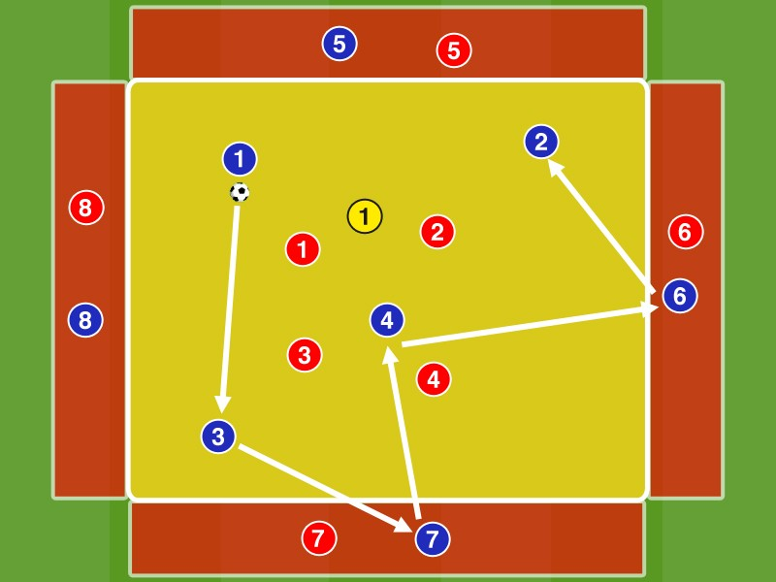Mark a 20 times 20-meter field. On each sideline then highlight a 5 meter wide red zone.

In field play 4 Blue against Red 4, with an additional neutral. In the red zone which is a blue and a red player is positioned.

Blue plays (with free contacts) with the neutral Yellow on possession and may involve the 4 outside players. The outside players have a maximum of 2 contacts.
Points: One point per bounce let an outside player on one of the 4 internal player, or on another external player.

The outside players run so free in the outer zones and dissolve it from its direct opponent, so that they can support the 4 players in the field optimally. They work with running feints and calling balls dynamically into free space. You should scan before the face-off the pitch, have to jump again bounce into the field to a teammate, or be able to move diagonally or vertically at best.

Variants:
- Position changes when pass to the outside
- The bounce let the external player may not take place on the passer, but must to a third party.
• 5: 5/6: 6 / ... in field
- Vivid Man-vs-man assignments in the field

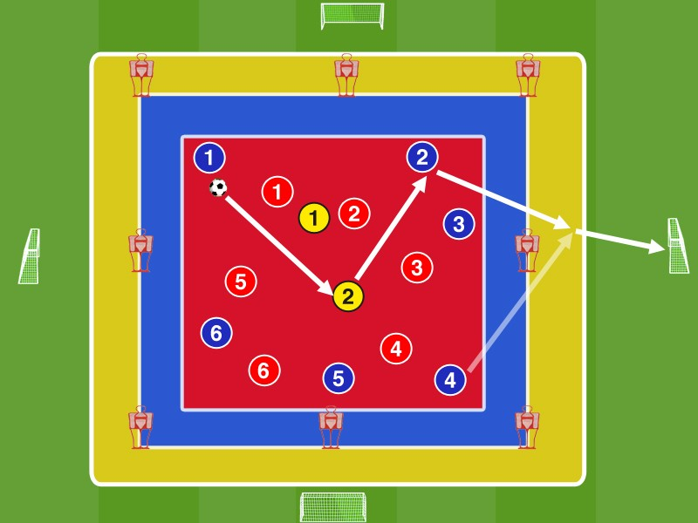An average taboo zone the size mark 30 by 30 meters and limited according to the figure with 8 dummies. Within the central zone a 20 by 20 meter red zone mark. Outside the central taboo zone mark a 40 by 40 meters large yellow zone and centered up on each side of line about 5 meters outside a Minitor.

In the inner red box Blue plays against Red in 6: 6 + 2 neutral yellow. After 5 passes in a row the team in possession may fit over the blue taboo zone away in the yellow zone into.

Erläuft a teammate to pass within the yellow zone and fits with the 1st or 2nd contact in one of the 4 Ministore gets the team a point.
The Blue should constantly scan in possession along with the 2 yellow neutrals the pitch, to see in the end zone in the narrowed field options to vertical / diagonal passes.
The incoming players decide situationally on the right moment to arrive in the promising areas of the outer yellow zone for the killer pass. You should consciously demand by walkways to pass while also accept to make walking distances without being played. Match with offside (the height of the dummies is deemed offside line)

Variants:
- Between passport and travel path to a dummy must reside (à diagonal pass routes)
- A player in / behind the yellow zone positioned must be blazing with the first contact on another player
• 5: 5/7: 7/8: 8 / ...

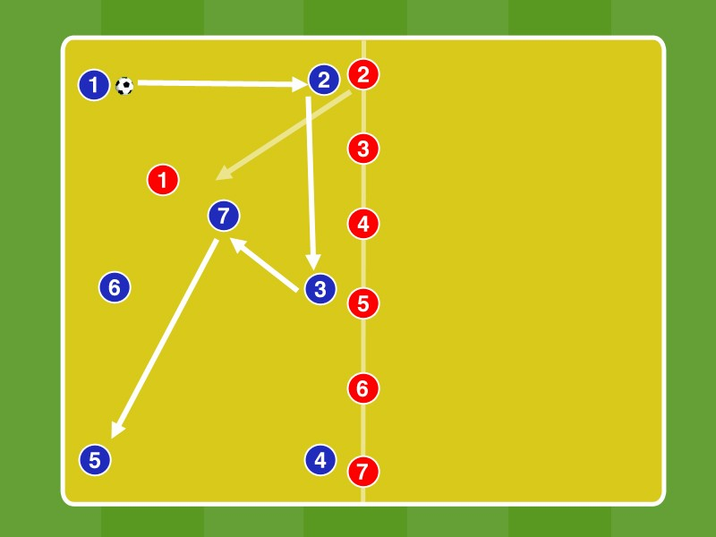A divide approximately 25 times 25 meters large field in 2 halves.

In box 1 Blue begins at 7: 1 against a Red with max. 2 contacts. 6 more red position to the centerline and are 2 - 7 numbered without the order blue white.

After each 7 passes another Red enters the field, so that a 7: 2 up to 7: 7 arises.

Once the ball Red conquered (Ball Out) to position all Reds in box 2 and begin to B1 in 7: 1, while position the rest of the Blue on the center line.

The ball ends get points depending on the number of opponents in the field at the time of ball loss.

The Blue should fan out clearly in possession with increasing number of opponents and form by the occupation of the center pass triangles. They are particularly scan the area around the center line in order to pre-oriented response to the incoming starting Defending can.

Variants:
- Only direct play allowed
• From 5: 1 to 5: 5 / from 6: 1 to 6: 6 / ...

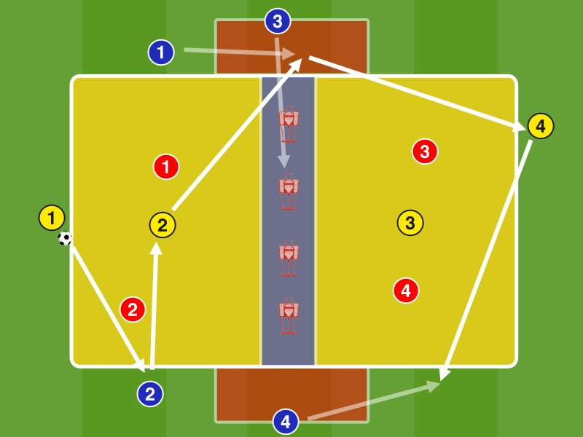Mark A 30 by 15 meters large pitch. In the middle of a 3 meters wide zone mark and in position 4 dummies. At the edge of two 10 x 5 meters large red areas mark.
In box 1 play B1 + B2 with yellow in the 4: 2 against Rot B3 and B4 are positioned at the edge of the red zone..

The goal is to min. 5 to switch passports resulted in box 2. This can only be done by over B1 and B2 pass on this in the red zone, while B3 / B4 this zone have cleared into the blue box inside.
The pass to fields change must not be defended by R3 and R4. After Blue plays with G3 and G4 in the 4: 2 against Rot in Field 2 on. In losing possession of blue Switch blue and red positions.

B3 and B4 are situational 'their' red zone clearing, which to create spaces for the inlet ends B1 and B2. They should leave their positions in the blue zone between the lines in order G1, G2, B1 and B2 to 5: 2 (6: 2) to support against Red.

B3 and B4 may be max. Three seconds remain in the blue zone. Will they (or B1 / B2 in the red zone) is not alluded to within 3 seconds, they must assume their original position. After contact with the ball in the blue zone they return to the edge of the red zone. With a field change to pass on B1 in the red zone back B1 and B4 at opposite in field. 2 B2 and B3 occupy the edge of the red zone.
positions: G1 = IV / B1 + B2 = AV / G2 = six / B3 + B4 = ÄMF player, or winger

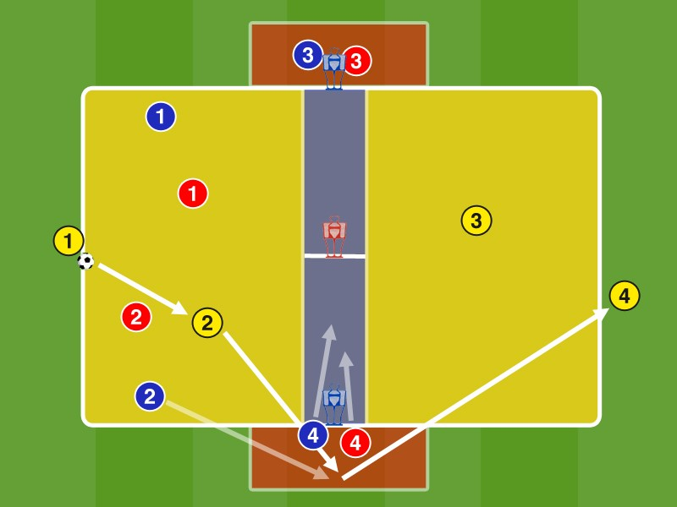Mark A 30 by 15 meters large pitch. In the middle of a 3 meters wide zone mark and this divide in the middle. At the edge of two 10 x 5 meters large red areas mark. Dummies placed according to the picture.
In box 1 play B1 + B2 with the positioned in the red zone B3 and B4 plus the two yellow neutrals in 6: 2 against Rot R3 and R4 defend the red zones plus one half of the blue central zone.. The goal is to min. 5 to switch passports resulted in box 2. This can be done with a passport from the blue zone out of B3 / B4 or with a ball of blue from the red zone. B3 / B4 to maximum of 2 seconds are allowed to stay in the blue zone. After changing fields Blue plays in 6: 2 in field 2 with G3 and G4 against Rot on. In losing possession of blue (= pass from red to G3 / G4 or ball is out) switch blue and red positions.
B3 and B4 are situational clearing 'their' red zone to provide R3 and R4 prior to the decision to either be allowed to enter the pass route into blue zone or the pass route in the red zone, in the B1 and B2 to close.
B3 and B4 may be max. 2 seconds remain in the blue zone. If they are not alluded to within 2 seconds, it must return the red zone again. With a field change to G3 or G4 moves to the blue, and again 2 players in the field and 2 player position in the red zone. R1 and R2 back to the defense, while R3 and R4 remain in the red zone.
positions: G1 = IV / B1 + B2 = AV / G2 = six, or ten / B3 + B4 = winger, or ÄMF player

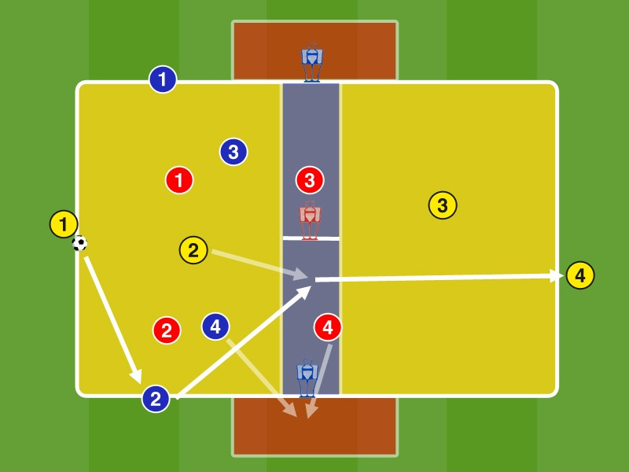Mark A 30 by 15 meters large pitch. In the middle of a 3 meters wide zone mark and this divide in the middle. At the edge of two 10 x 5 meters large red areas mark. Dummies placed according to the picture.
In box 1 play B3 + B4 with the positioned on the side lines B1 and B2 plus the two yellow neutrals in 6: 2 against Rot R3 and R4 defend one half of the blue central zone.. The goal is to min. 5 to switch passports resulted in box 2. This can be done with one pass through the blue zone, or out of the blue zone out or with a ball of B3 or B4 of the red zone out, which may reside in the red zone, the two more than 2 seconds. After changing fields Blue plays in 6: 2 in field 2 with G3 and G4 against Rot on. In losing possession of blue (= pass from red to R3 / R4 or ball is out) switch blue and red positions.
B3 and B4 are situational freely draw in 'their' red zone to provide R3 and R4 with the decision either to close the pass route into the red zone, or the pass trail in the blue zone, or by the blue zone pass.
B3 and B4 may be max. 2 seconds remain in the blue zone. If they are not alluded to within 2 seconds, it must return to the field again. You must then again at least. 1 time to touch the ball in the box, in order to re-enter the red zone may. With a field change to G3 or G4 moves to the blue, and again 2 players in the field and 2 player position on the sidelines. R1 and R2 back to the defense, while R3 and R4 remain in the blue zone.
positions: G1 = Secher / B1 + B2 = AV, or ÄMF player / G2 = six, or ten / B3 + B4 = tens, or winger

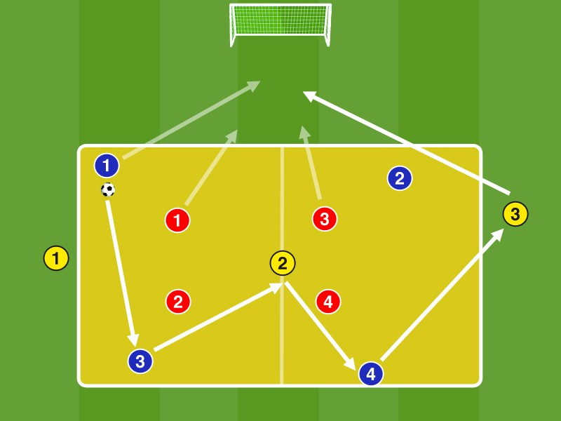Marking an approximately 34 x 14 meters large field. Behind a distance of about 25 meters square and occupy a goal with a goalie.

Blue plays the field in 7: 4 with 3 neutral Yellow to Red 2 Yellow are positioned at the end faces, one in the field..
Blue scores one point for 8 passes in a row. They should after min. 8 passes in a row on the outer neutrals G1 and G3 play on goal. The Yellow have a maximum of 2 contacts. In losing possession of blue Switch blue and red right tasks / positions.

positions:
G1 + G3 = AV, or ÄMF player / G2 = 10 B1 + B2 = Forward, or peak + 10
B3 + B4 = 6, or 10 / 8er
Blue fans out in ball far and in compliance with the neutral Yellow remotely to span the widest possible net.
By fanning out in breadth and depth to pass lines open to the free man G2 between the lines, which should be actively sought from the possession takes team. The middle Neutral scans the pitch to optimally pre-oriented to be.

. After at least 8 passes in a row playing G1 / G3 (if possible directly flat) behind the chain to the inlet ends Blue on goal at 7: 4. If red deep position on the edge of the playing field, so that a pass behind the chain is not very promising, to blue to continue playing with yellow in the field to score points there through contacts and so red in again take the field (see. Away games of the chain) to create new spaces behind the chain.

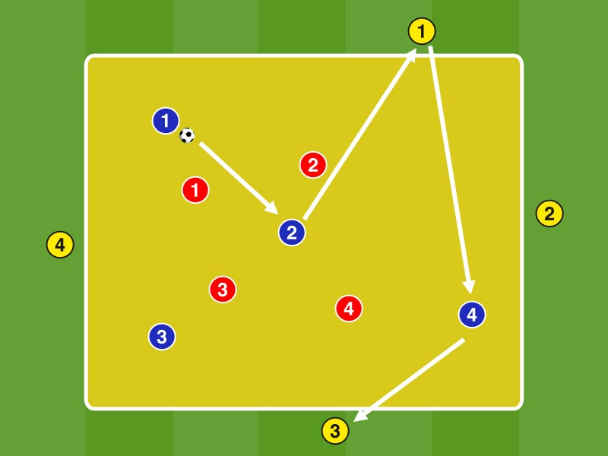Marking an approximately 18 times 18 meters large field.

Blue plays in the field with the 4 outer Yellow in 8: 4 vs. Red.

After 8 consecutive contacts leaves red field, and exchanges with yellow positions. Yellow defended in the field against blue, now in 8: 4 playing with red.

Succeed Steady red ball profit before blue and yellow have played 8 contacts, they play together with yellow against blue on.

Blue fans out in ball far and in compliance of the Yellow remotely to span the widest possible net. Blue occupied the possibility always the center to generate optimal fit triangles.

By changing the opponent by 8 contacts the team in possession is always in the field with respect to a maximum pressure. You need to preorienting optimal after 8 passes, to respond to the new opponent can. They consciously choose after 5-7 passports which regions they play on, to keep the enemy pressure after the position / job change as low as possible.

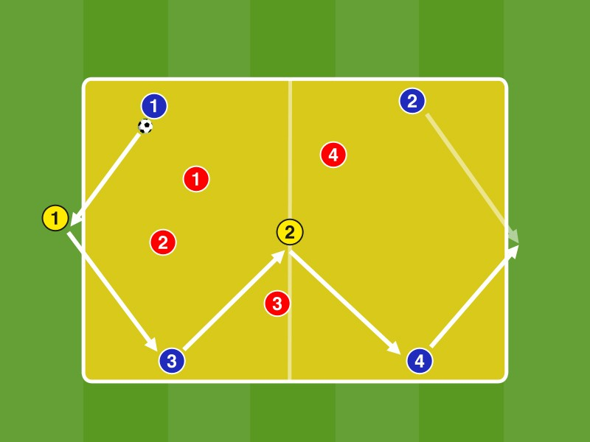Mark A about 28 by 16 meters large field.

Blue plays the field in 6: 4 with 2 neutral Yellow to Red 1 Yellow is positioned at one of the ends, one in the field..

Blue scores one point for 8 contacts.

positions:
G1 = IV / G2 = six
B1 + B3 = AV, or IV in 3 chain R1 + R2 = Forward

Blue fans out in ball far and in compliance with the neutral Yellow remotely to span the widest possible net. By fanning out and the resulting outer focusing registration lines open to the free man G2 between the lines, which should be actively sought from the possession takes team. The middle Neutral scans the pitch to optimally pre-oriented to be. He consciously always retains the vertical pass into the depths to a Blue, or G1 in the eye, either directly or via a third Blue.

The blue should consciously always occupy the free end side, so as to create depth. Depending on the direction of play, this would mean a pass at the top, or a passport to shift to a abkippenden sixes.

The Reds defend from the inside out and then fan after winning the ball immediately, to pass into a stable possession can. Blue goes losing possession immediately to counter pressing.

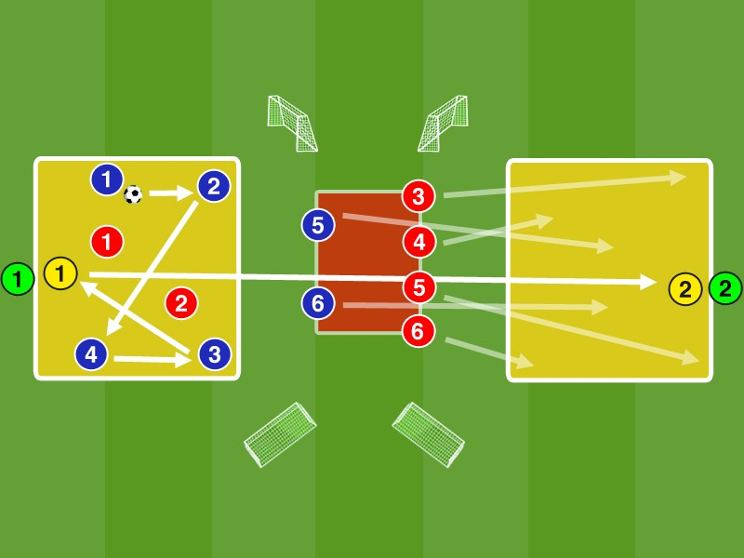Mark Two is about 10 by 10 meters large fields, at a distance of about 30 meters. Between them highlight an approximately 4 by 2 meters large red central zone.

Blue plays in box 1 in 5: 2 with G1 against Rot GR1 is positioned outside of the field.. G2 and GR2 are located in / on the box 2. In the red zone are shown in the illustration four red and two blue.

After min. 6 contacts resulted Blue plays the chip / air ball on G2 in box 2. GR 2 defends against G2, may the field but only entered once the ball has crossed the red zone.

The 4 Red and Blue both from the central zone back soon touched the ball G2 has to in box 2 and
play after the ball fuse together with G2 in 5:. 2 The Blue and Red of field 1 occupying positions in the red zone (blue box closer to 1 than red).

Points: Blue one points against red and yellow against Grün.1 point per Arrived Flugball for possession ends. 1 point per ball backup for G1 or G2. In winning the ball in 2: 5 can score a point with a ball in one of the two mini-goals, the two players. The same goes for ball conquest of GR1 and GR2.

positions:
G1 + G2 = Forward GR1 + GR2 = IV

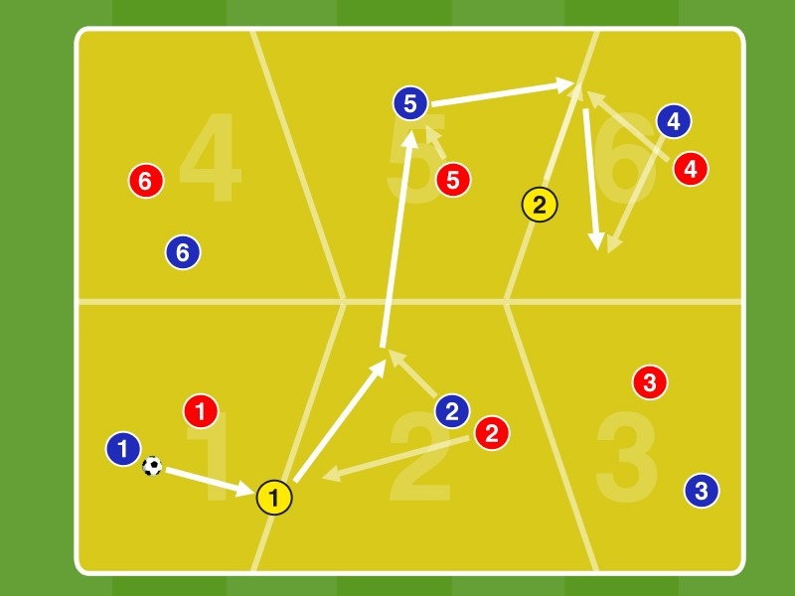Mark A 30 by 20 meters large field. The field shown in the figure in 6 subfields divide.

The blue one and assign a red player a subfield. The players are allowed to move only in their respective zone. The two neutral Yellow may move only on the lines which delimit the subfields.

Blue plays with the two neutrals in the complete field against Rot in 8: 6, where the players must keep their respective zone. In losing possession Red plays with the two yellow neutrals.

Points: Pro 8 seconds possession 1 point.
Blue is in possession along with the yellow neutral 2: 1 majority situations forth. Here, the pass receiver is moving so out of the cover shade in the back of the opponent, that an open pass line is created and it is playable.

The Reds are trying to build on the other hand the largest possible coverage shadows in the game against the ball and win the ball that way. By 8-second rule has to defend Red forward to put pressure on the ball ends.
The two neutrals anticipate the game situation to instantly recover 2: to produce 1-situations.

Variant: The actions of both neutrals must be made in exchange, is thus alluded G1, it is long out of the game until G2 had a ball action. This provocation rule requires increasingly a game relocations.

4 vs. 4 + 5N 'FREE DRAW FOR Diagonal DIAGONAL IN THE HALF TRACK'

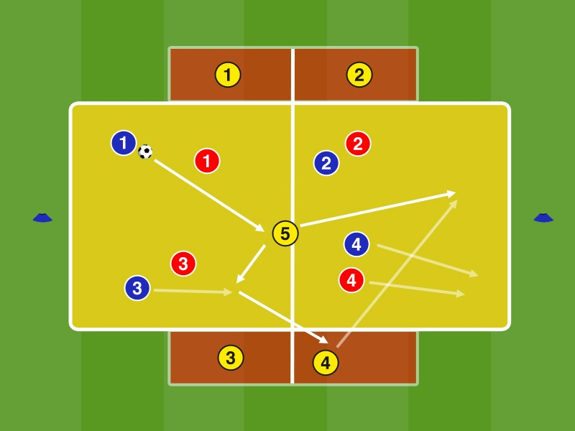Mark A about 35 by 20 meters large field. On the sides of two 16 by 2 meters large red areas mark and this divide in the middle.

Depending assign a yellow neutrals a red subfield. In field play 4 Blue against Red 4 with an additional neutral G5.

The objective is to dribble the team in possession after a pass of the 4 outer neutrals over a baseline. If this succeeds, the possession of the ball player dribbles around the cone and continues to play in the field in possession.
Points: 1 point for the over dribbling a baseline. In addition, 1 point for 8 passes in a row.

Blue uses the field the majority of the additional neutral in order for a free by pulling motion to require the pass toward the baseline and pull free the other to pass route to the center. R4 must absorb through the free drawing B4 its path. G4 decides if he plays in the diagonal-diagonal to B4, or the center on G5, through the opening ball line.

The outer neutrals scan the field to detect compressions and rauszuverlagern diagonally when needed to attack the other baseline.

Variant: assigning game play direction, blue and red respectively a baseline.

3 + 1 N + 2 vs. 3 'BETWEEN THE LINES'

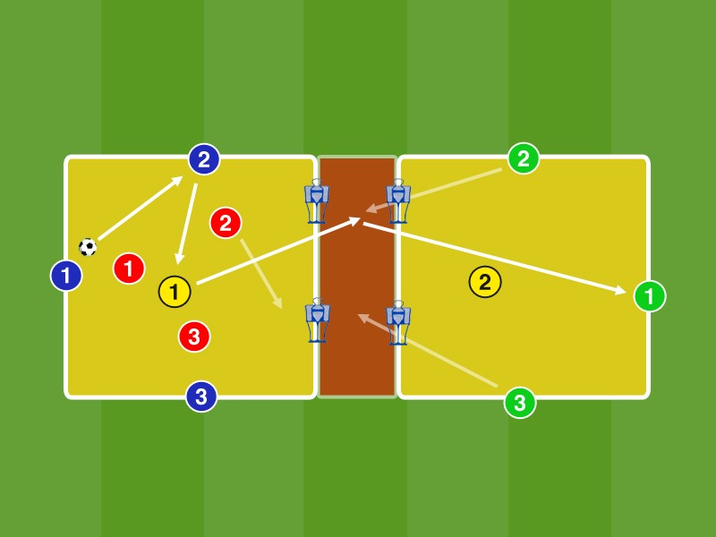Mark Two approximately 15 x 15 meter field. In between there is a 5 meter wide red zone, at the edge 4 dummies positioned.

Possible locations:
Blue plays in field 1 with the Neutral G1 in 4: 3 against Red Two Green can to support the ball ends tilt in the red zone, so a 6:. 3 to produce. A Red must defend in the red zone into. In BG of red this play with G1 vs. Blue.
The aim is to change for the team in possession after a pass to an open in the red zone into the field to GR1. If this goes red to Defend in box 2 after.
Points: 1 point for a change to another field. In addition, 1 point for 6 passes in a row.

B1 = six / B2 + B3 = 10, or 8er / GR2 GR3 + = AS / GR1 = tip, or B1 = IV / B2 + B3 = AV / GR2 GR3 + = six / GR1 = 10

While Blue fans out in possession, tilt 2 Green between the lines in the red zone from to support Blue in possession and alluded as a free man between the lines and turned up in the depth to play. Red tries to pass lines to connect between the lines, but the possibility to cover the shadow to defend forward to winning the ball.

Variants:
It may tilt only 1 Green between the lines in the red zone
The Abkippende in the red zone must be clapping on a Blue, which then may change the pitch



